Central Recordkeeping Agency



Standard Operating Procedure for Nodal Office (Monitoring Office)
For
Error Rectification Module (ERM)

Contents
1. Preface 3
2. Acronyms and Abbreviations 4
3. Error Rectification Module 5
(a). Excess amount transferred to Trustee Bank (only for CG Sector) 6
(b). Excess amount transferred to a PRAN 15
(c). Transfer to PRAN 1 instead of PRAN 2 25
(d). Non-NPS Subscriber withdrawal 36
4. Views by PrAO 47

Preface

Government of India (GOI) introduced a new Defined Contribution Pension Scheme known as the National Pension System (NPS) replacing the existing system of Defined Benefit Pension System vide Government of India, Ministry of Finance, Department of Economic Affairs Notification, dated 22nd December 2003. The NPS came into operation with effect from 1st January 2004 and is applicable to all new employees of Central Government service, except Armed Forces, joining Government service on or after 1st January 2004. The employees of Central Autonomous organizations, State Governments/Union Territories (UTs) and the Autonomous organizations of the respective State Government/UT are also eligible to join the NPS. The employees who join the NPS are known as ‘Subscribers’ in the NPS.

GOI established Pension Fund Regulatory and Development Authority (PFRDA) on 10th October 2003 to develop and regulate the Pension Funds under the NPS. PFRDA appointed National Securities Depository Limited (NSDL) as the Central Record Keeping Agency (CRA) to maintain the records of contribution and its deployment in various pension fund schemes for the employees. PAO/DTO/POP-SP (hereafter referred as PAO) provides the subscriber details to CRA and remits the funds to Trustee Bank which in turn transfers the funds to Pension Fund Mangers (PFMs) for investment. Units are allotted to the subscriber’s PRAN based on their contribution amount. At the time of providing the subscriber contribution details, PAO may remit the incorrect amount, which has to be rectified in the subscriber record. This document describes the Standard Operating Procedure to be followed by the Nodal Offices for rectification in the CRA system.

Acronyms and Abbreviations

The following definitions, acronyms & abbreviations have been used in this manual:

ACRONYM | DESCRIPTION
CRA | Central Record Keeping Agency
DTA | Directorate Treasury of Accounts
DTO | District Treasury Office
ERM | Error Rectification Module
I-PIN | Internet Personal Identification Number
NPS | National Pension System
GOI | Government of India
TS | Transaction Statement
NSDL | National Securities Depository Limited
PAO | Pay and Accounts Office or equivalent entity such as DTO/POP-SP
PFRDA | Pension Fund Regulatory & Development Authority
POP | Point of Presence
POP-SP | Point of Presence-Service Provider
PRAN | Permanent Retirement Account Number
PrAO | Principal Accounts Office or equivalent office such as DTA/ POP

Error Rectification Module

PAO has to upload Subscriber Contribution File (SCF) in NPSCAN/CRA system and remit the pension contributions to the Trustee Bank. However, there have been instances wherein the accredited bank had transferred amount in excess of the SCF. Further, there have been instances wherein the PAOs may have committed errors in uploading the SCFs. In a nutshell, the PAOs/Accredited Banks may have committed the following errors:

- Excess Transfer to Trustee Bank*
- Excess Transfer to a PRAN
- Amount wrongly credited in PRAN 1 instead of PRAN 2
- Non-NPS Subscriber withdrawal

*In the present scenario, all the funds are returned which do not get matched within the next business day. Therefore, ‘Excess transfer to Trustee Bank’ module will facilitate only those remittances which have been done before May 1, 2012.

The succeeding pages describe SOP to be followed by the Nodal Offices for rectification of such errors.

3 (a). Excess amount transferred to Trustee Bank (only for CG Sector)

This scenario consists of a situation wherein PAO has transferred excess funds to the Trustee Bank. PAO may/may not have uploaded the corresponding SCF in the CRA system and the entire amount is invested and is part of the CG Pool Account. In order to resolve the situation, the PAO has to capture a request in CRA system through ‘Error Rectification Module’.

Funds can be remitted back to the PAO only if the amount is lying in the Pool. PAO may contact Trustee Bank with the Fund Transfer Details (FTD) to check whether the amount has been adjusted against any SCF or not. If the funds have been adjusted with other SCF, amount cannot be remitted back to PAO. Below are the activities which need to be performed for rectification of error:

- Capturing of Request by PAO
- Verification of Request by PAO
- Authorisation of Request by PrAO
- Confirmation by Trustee Bank
- Verification by Trustee Bank

Capturing of Request

PAO will login into the CRA system (www.cra-nsdl.com) by its User ID and I-Pin. Please refer Figure 1.

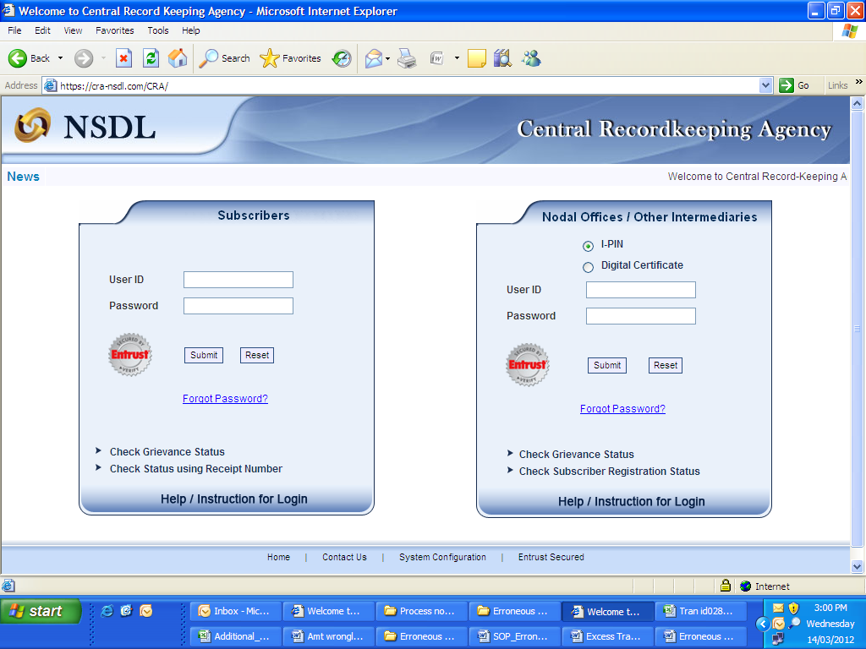
(Figure 1)
Once PAO logs into the CRA site, there is a menu of ‘Error Rectification Module’. User will click the sub-menu ‘Rectification of excess transfer to Trustee Bank’. Please refer Figure 2.
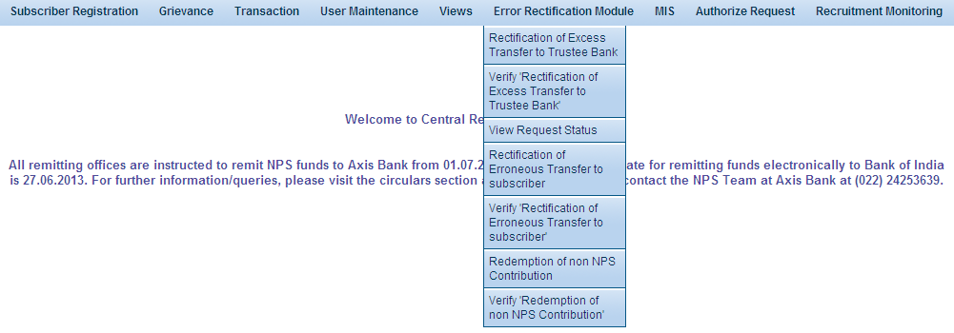
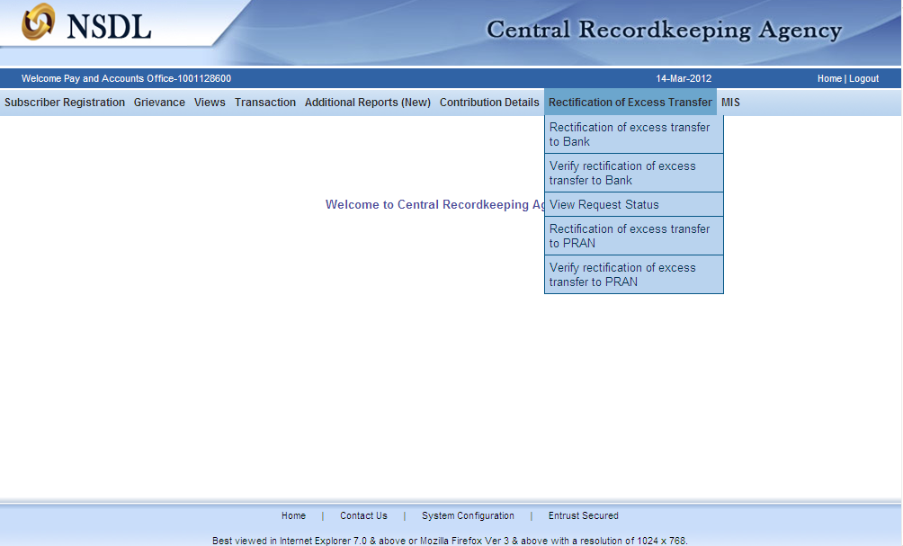
(Figure 2)

User will be shown the Welcome page of this menu. A summary containing information relevant to the menu has been provided in the Welcome page. Please refer Figure 3.
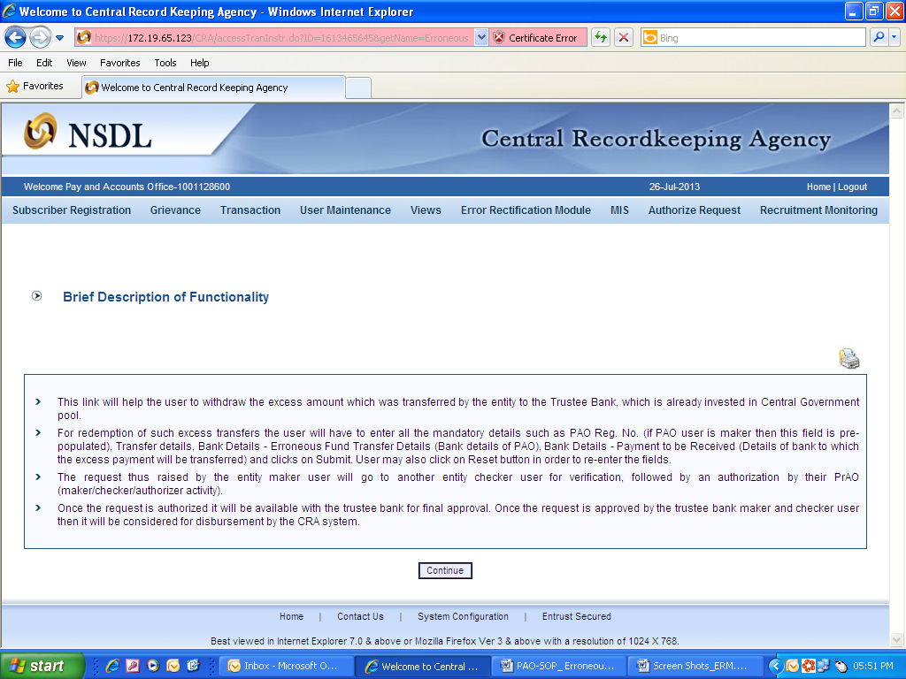
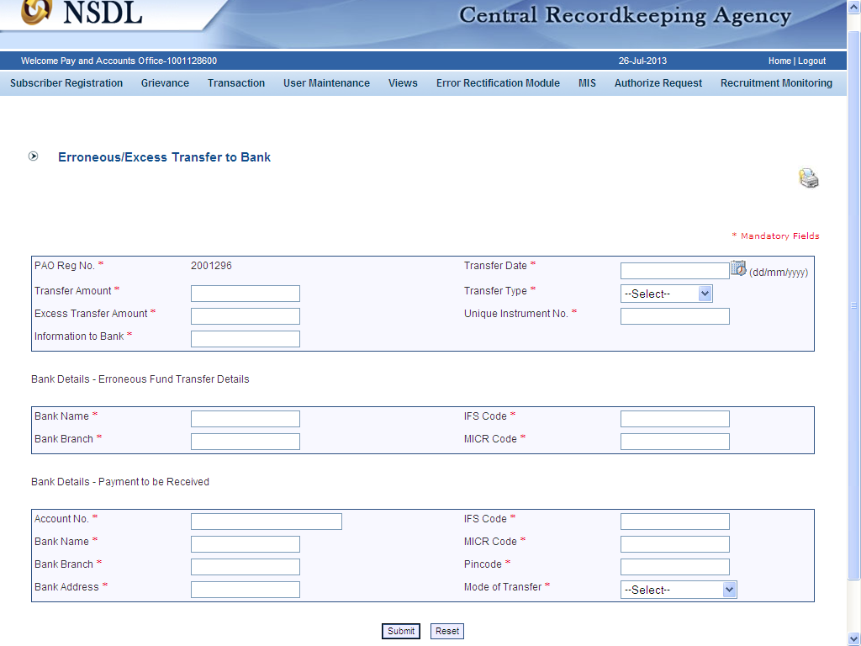
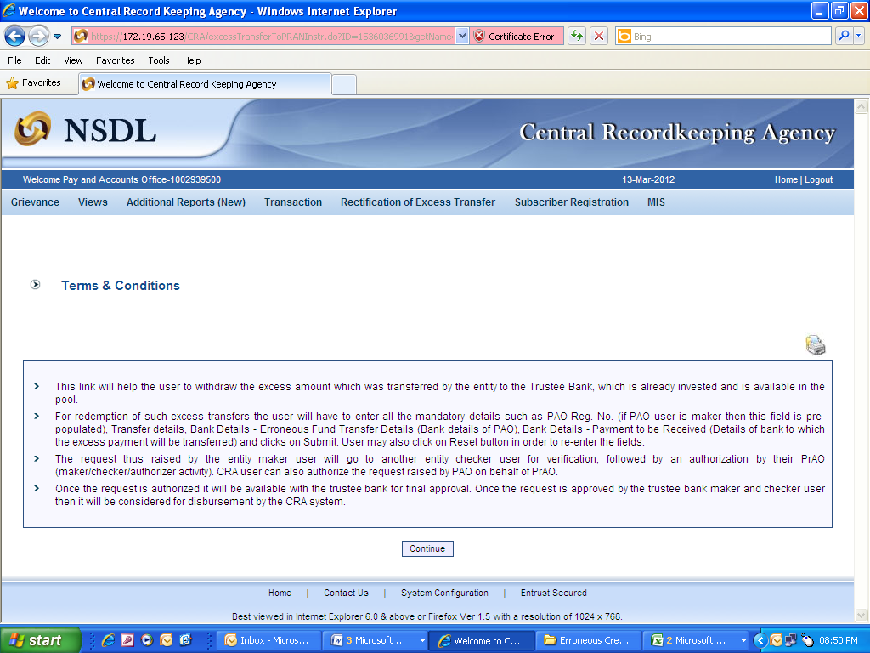
(Figure 3)

User has to click the ‘Continue’ button to capture the request. There will be three sections (as provided below, Please refer Figure 4) where User has to provide the details:

- First Section: First section will be of the FTD pertaining to the excess amount transferred. This will include Unique Reference Number (In case of RTGS, it is UTR and in case of NEFT, it is Reference No.), Transfer amount, Transfer date, Transfer type, Excess Transfer amount. There is also a field where User can provide remarks to the Trustee Bank. User can provide maximum 150 characters in the remark field. User should provide the correct fund transfer details which will help the Trustee Bank to identify the amount.

- Second Section: User will provide it’s Bank Details such as ‘Bank Name, IFS code, Bank Branch and the MICR code’ (MICR code is mandatory only in case, if ‘Type of Transfer’ selected as ‘Cheque’) through which funds have been transferred to the NPS Trust account. There will be certain validations while capturing the request such as ‘If the User provides less than 16 digits UTR number, CRA system will show proper error message’. If the MICR is less than nine digits, message will be shown to the User ‘MICR should be of nine digits’. Same validation is there for IFS code. If the IFSC is less than 11 digits, message will be shown to the User ‘IFSC should be of 11 digits’.

- Third Section: In the last section, PAO has to provide the Bank details as ‘Bank Account Number, Bank Name, Bank Branch, IFS code etc.’ where PAO requires Trustee Bank to remit back the funds. PAO should mention the Government Bank account which needs to be credited by the Trustee Bank.

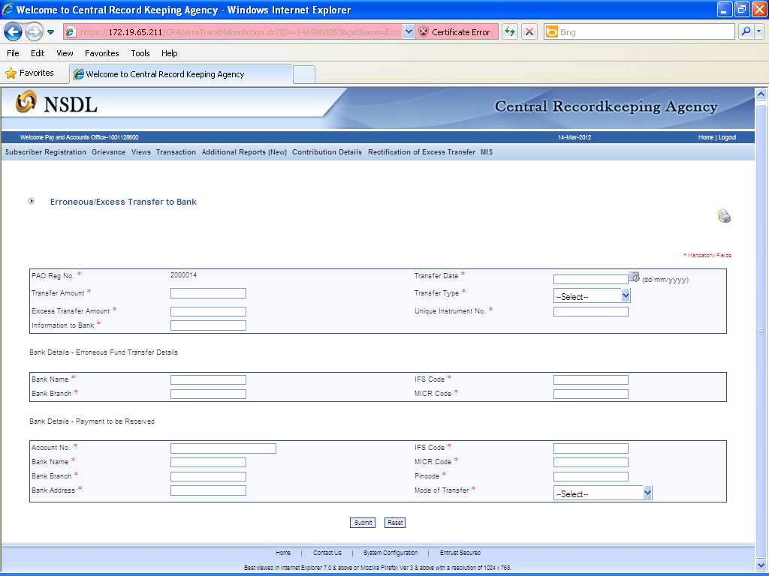
(Figure 4)

After providing all the details, User clicks the Submit button, confirmation page will be shown to the User as below
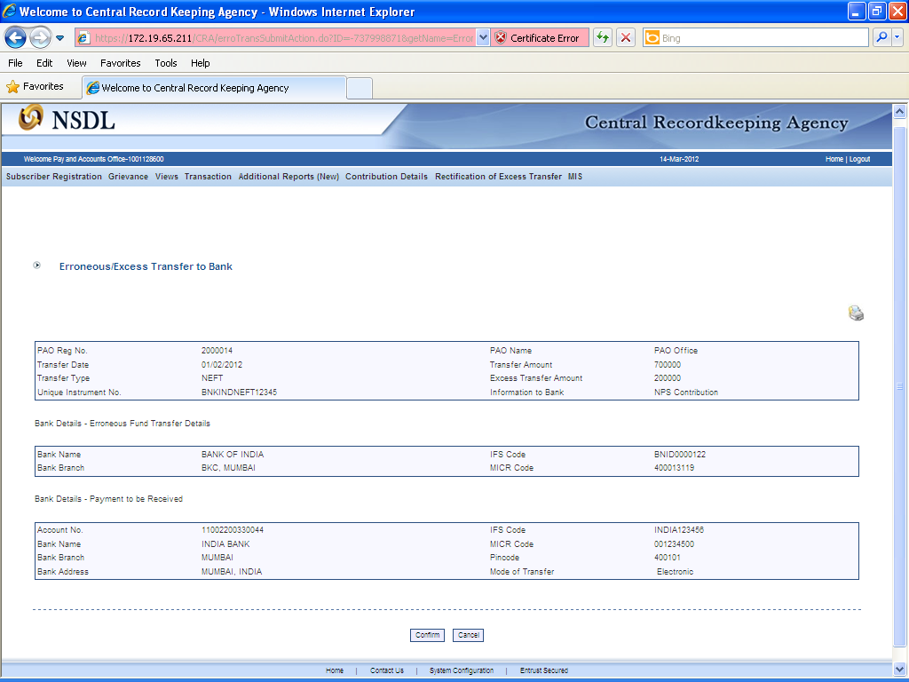
(Figure 5)

User has to click the ‘Confirm’ button to generate the Acknowledgement Number. User should note down the Acknowledgment number for tracking the status of the request. Please refer Figure 5.
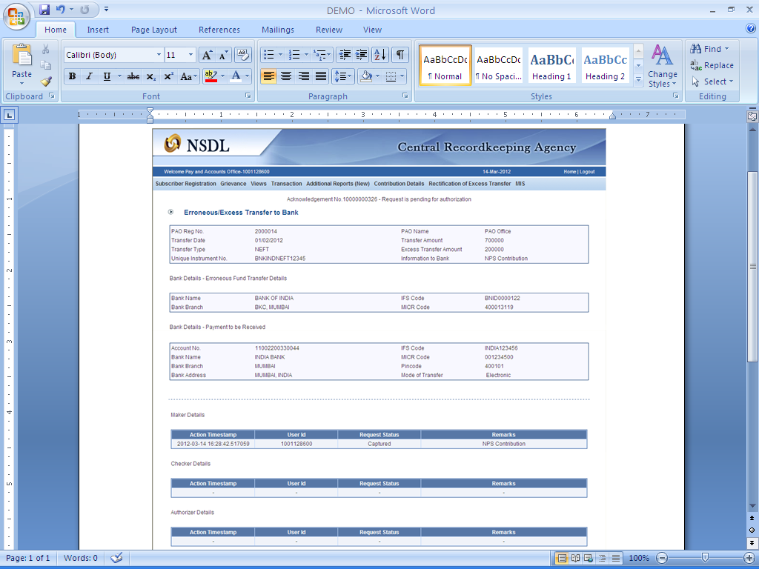
(Figure 6)
Verification of Request

Another User will login into the CRA site using the second User ID and I-PIN. Once User logs into the site, User will click on the sub-menu ‘Verify rectification of excess transfer to Trustee Bank’.

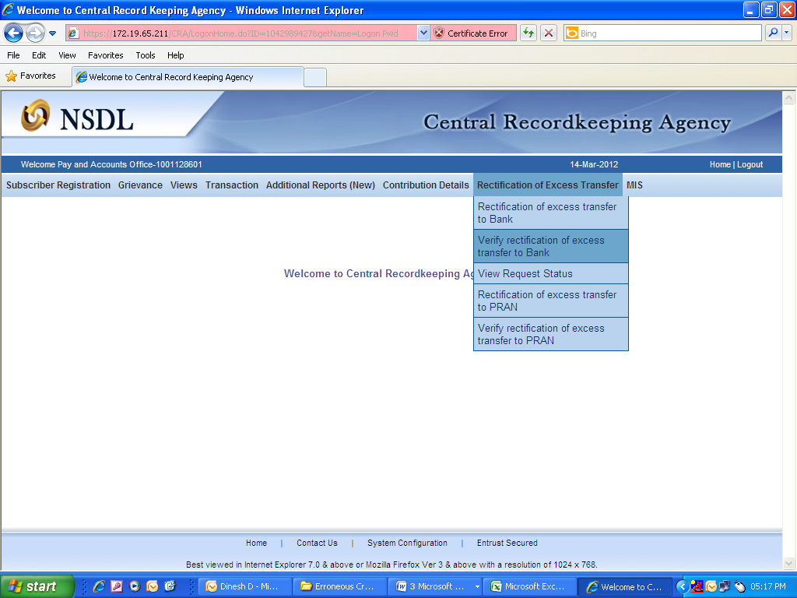
(Figure 7)

All the pending requests will be shown to the User after clicking the ‘Verify Rectification of Excess transfer to Trustee Bank’. User can also search for a particular request by providing the Acknowledgement ID and ‘Request Type (Excess transfer to Trustee Bank, Excess Transfer to a PRAN)’. User can also search the request by providing the ‘Date Range’. Once User provides the search fields, Acknowledgment IDs (hyperlink) will be provided to the User. Please refer Figure 8.

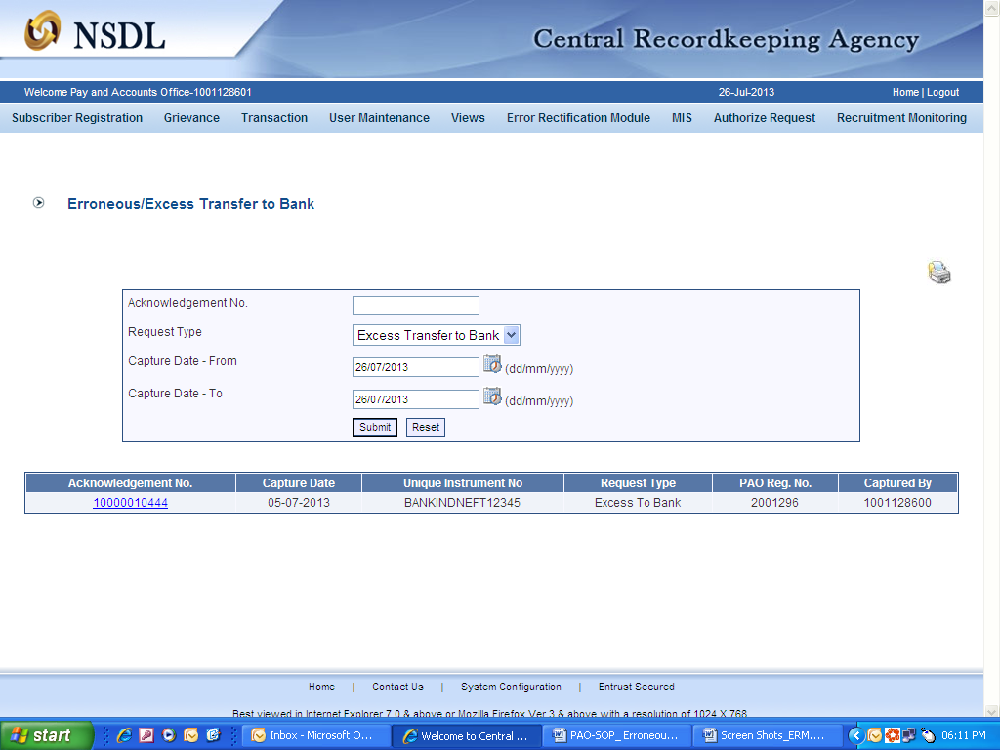
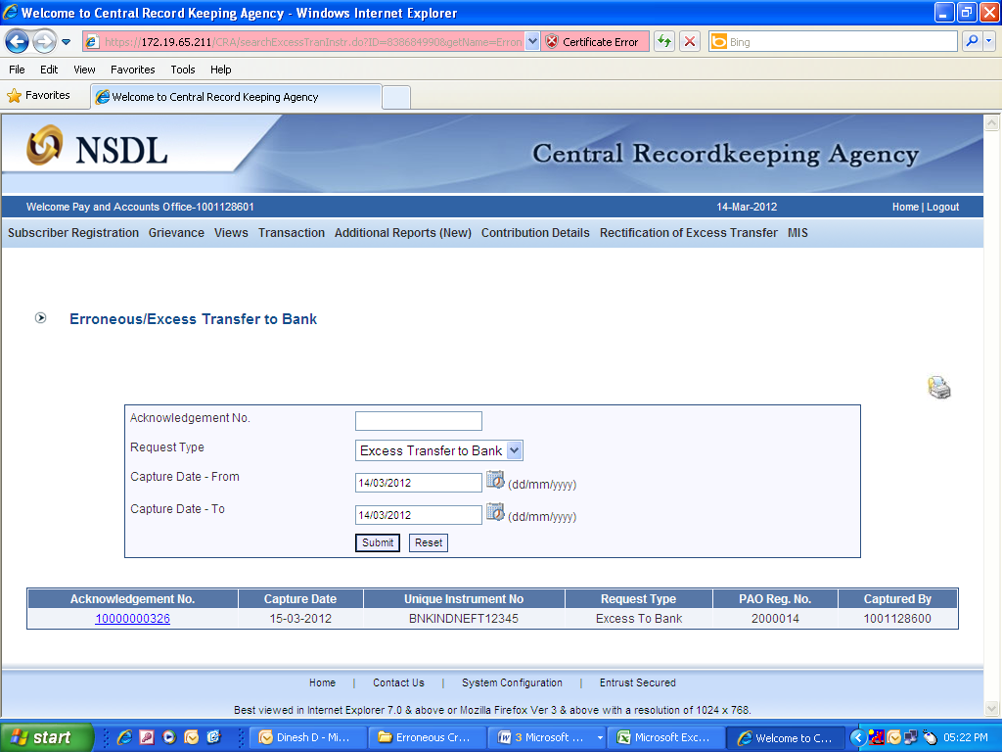
(Figure 8)

Once User clicks the hyperlink, rectification capture details will be shown to the User. User should check all the details captured by the Maker. Based on the details captured, User has the option to ‘Accept’ or ‘Reject’ the request. User can also provide remarks while verifying the request for his/her reference. For example, if the User observes that the Bank details provided are not correct, User should reject the request with the remarks ‘Incorrect Bank details captured’. Please refer Figure 9.

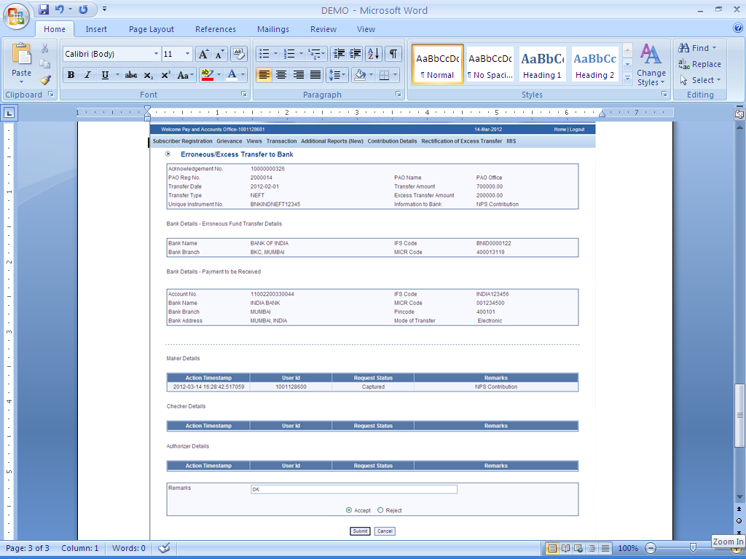
(Figure 9)

When the User submits the request, message ‘Request Verified Successfully, Acknowledgement ID is 100XXXXXX Pending for authorization’ will be shown to the User. Kindly note, if the PrAO User at the time of authorization, rejects the request, PAO User has to capture a fresh request for rectification, if needed.

Once request is authorized by PrAO and approved by Trustee Bank, the units credited in the subscriber account (equivalent to the contribution amount credited) erroneously would be redeemed. Amount (in Indian Rupees) equal to the initial investment would be credited back to the PAO and excess realized (if any) would be credited to the Investor’s Awareness Account maintained with the Trustee Bank. For example, PAO X had remitted Rs. 10,000/- funds inadvertently on March 22, 2008. Let us say, as per NAV Rs. 10/-, 1000 units were created for Rs. 10,000/- in the CG Pool. On February 15, 2012, PAO X has requested for refund of Rs. 10,000/- and Trustee Bank has identified the excess remittance which has not been adjusted against any SCF. Trustee Bank will verify the request (say on February 20, 2012) and units will be redeemed on February 21, 2012. If the NAV is Rs. 13.50/-, amount Rs. 13,500/- (1000 units X 13.50) will be transferred to the withdrawal account. Trustee Bank will transfer the withdrawn amount (to the extent of Rs.10,000) to the PAO’s Bank account, remaining Rs.3,500 will be transferred to the Investor Awareness Account.

Authorisation of Request

PrAO User will be able to view the request verified by the PAO. User will click the menu ‘Error Rectification Module’ and sub-menu ‘Authorise rectification of excess transfer to Trustee Bank’. Please Refer Figure 9.1.

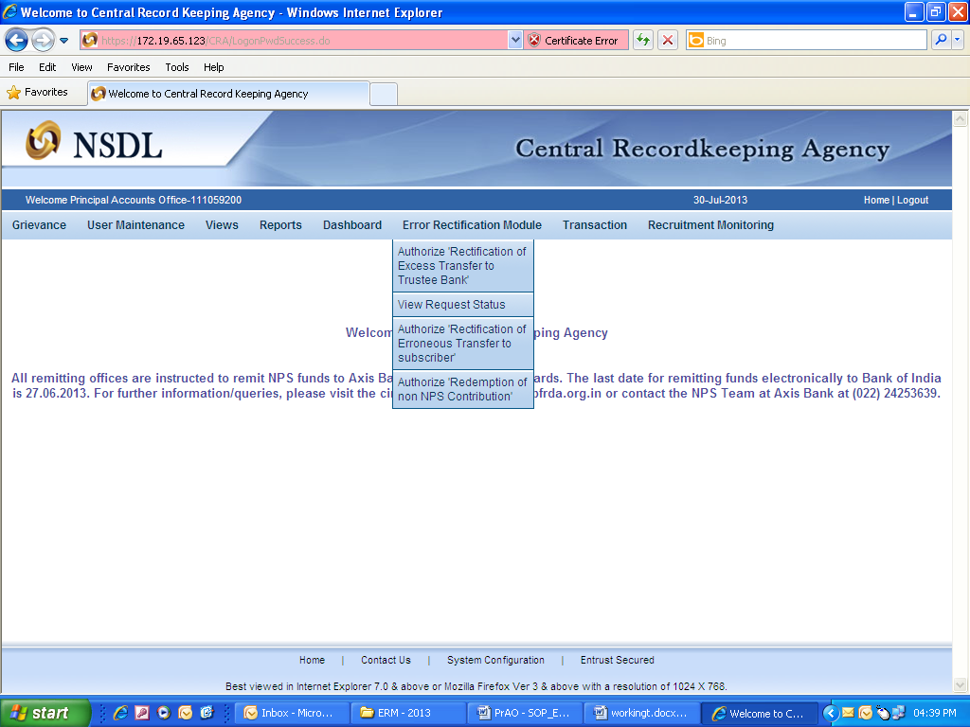
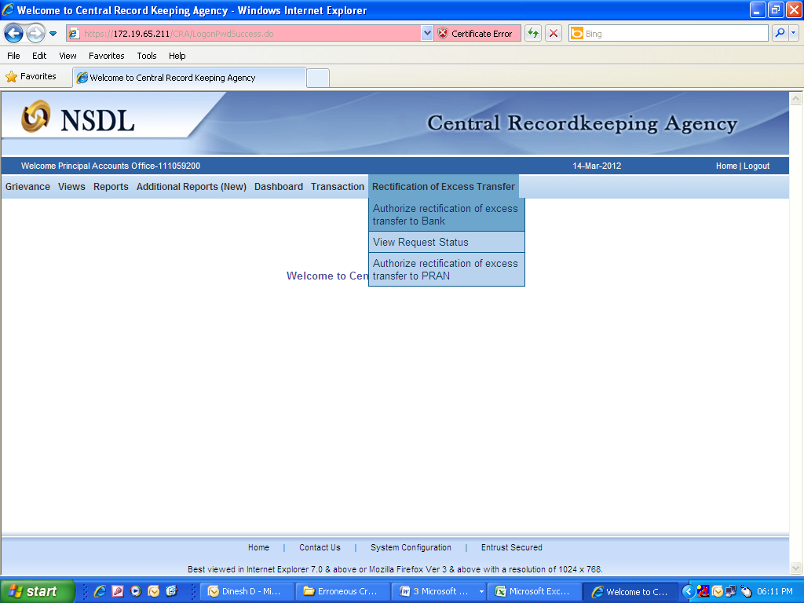
(Figure 9.1)

All pending requests will be shown to the User after clicking the ‘Authorise Rectification of Excess Transfer to Bank’. User can also search for a particular request by providing the Acknowledgement ID and ‘Request Type’. User can also search the request by providing the ‘Date Range’. Once User provides the search fields, Acknowledgment ID hyperlink will be provided to the User. Please refer Figure 9.2.

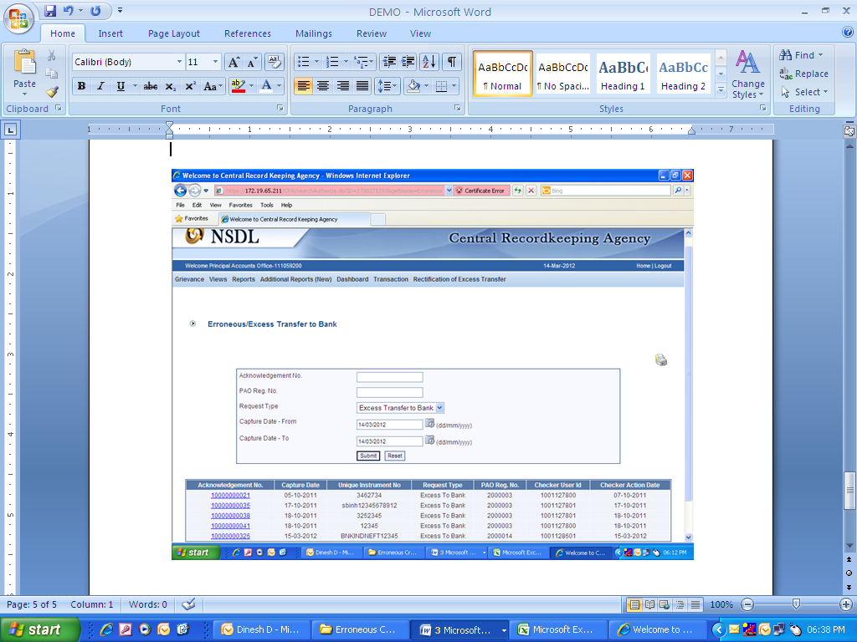
(Figure 9.2)

Once PrAO User clicks the hyperlink, rectification details will be shown to the User. PrAO has to check the details verified by the PAO. PAO should provide erroneous credit details to PrAO offline so that PrAO User can authorise the details in CRA system. PrAO User should check all the details entered by the PrAO Users based on the offline details received from the PAO such as Transferor Bank Details, Payment to be received in the Bank account etc. User has the option to ‘Accept’ or ‘Reject’ the request. User can also provide the remarks in ‘remarks field for their reference while processing the request. Please refer Figure 9.3.
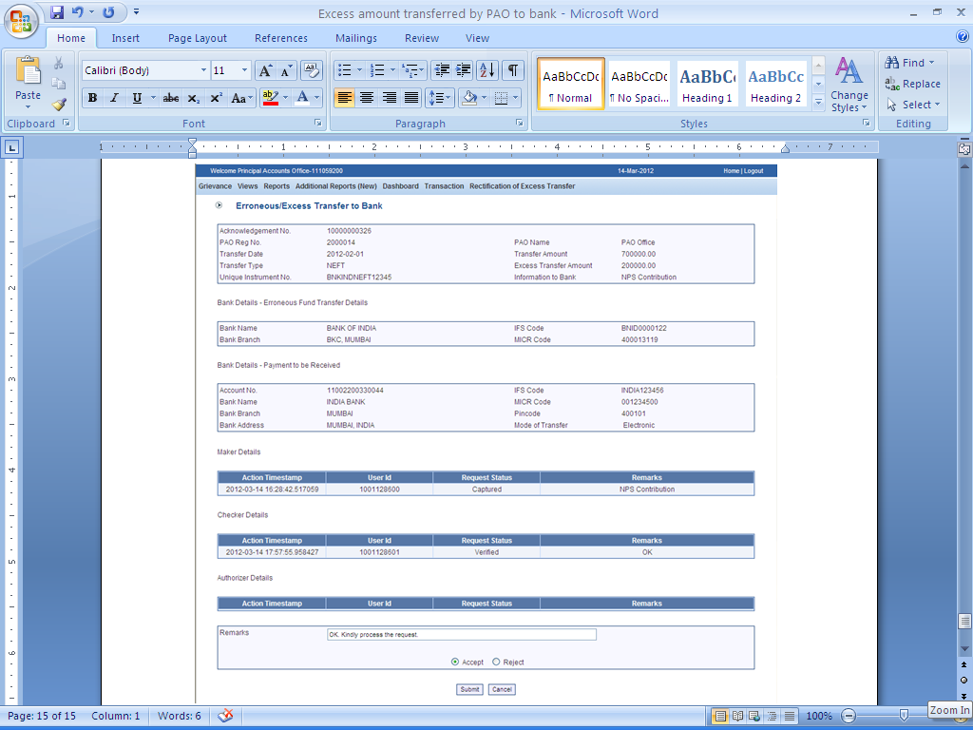
(Figure 9.3)

When the PrAO User submits the request, ‘Request authorised successfully, Acknowledgement ID is 100XXXXXX’ message will be shown to the User. Please refer Figure 9.4.

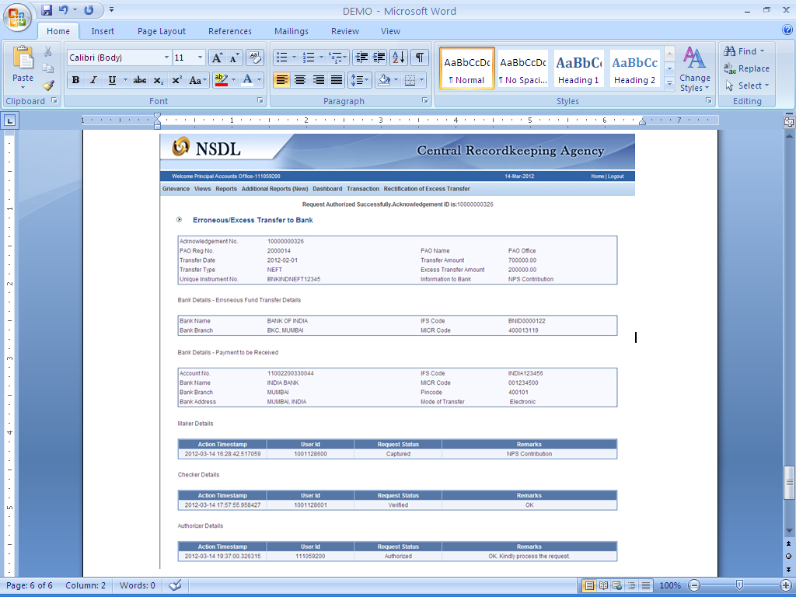
(Figure 9.4)

Request will be forwarded to the Trustee Bank for the confirmation of the funds transferred by the PAO. CRA has provided online functionality to the Trustee Bank to confirm the request.

Once request is approved by Trustee Bank, funds will be transferred to the PAO’s bank account.

3 (b). Excess amount transferred to a PRAN

In some instances, PAO may have erroneously transferred excess amount to a PRAN and the amount has been credited into the subscriber account. The resolution of these cases can be done by the PAO.

Following are the validations which are in place for capturing the request in CRA system:

- PAO can capture the request for only that record which has been uploaded by it, irrespective of whether at present the Subscriber is associated with that nodal office or not. However, the subscriber should not have moved out of the sector to which the PAO belongs.

- Unless and until the request (captured earlier) is verified for a PRAN for the specific entry, PAO will not be able to capture a fresh entry for the same. For example, PAO has captured the request for withdrawal of regular credit of April’12. Unless this request is effectively completed, PAO will not be able to capture any other request for withdrawal of credit pertaining to April 2012 for this particular subscriber.

- In these cases, the units credited in the subscriber account (equivalent to the contribution amount credited) erroneously would be redeemed. Amount (in Indian Rupees) equal to the initial investment would be credited back to the PAO and excess realized (if any) would be credited to the Investor’s Awareness Account maintained with the Trustee Bank.

Capturing of Request

PAO will login into the CRA system (www.cra-nsdl.com) by using its User ID and I-PIN. Please refer Figure 10.

(Figure 10)

Once PAO login into the CRA site, ‘Error Rectification Module’ menu will be shown. User will click the sub-menu ‘Rectification of Erroneous Transfer to subscriber’. Please refer Figure 11.

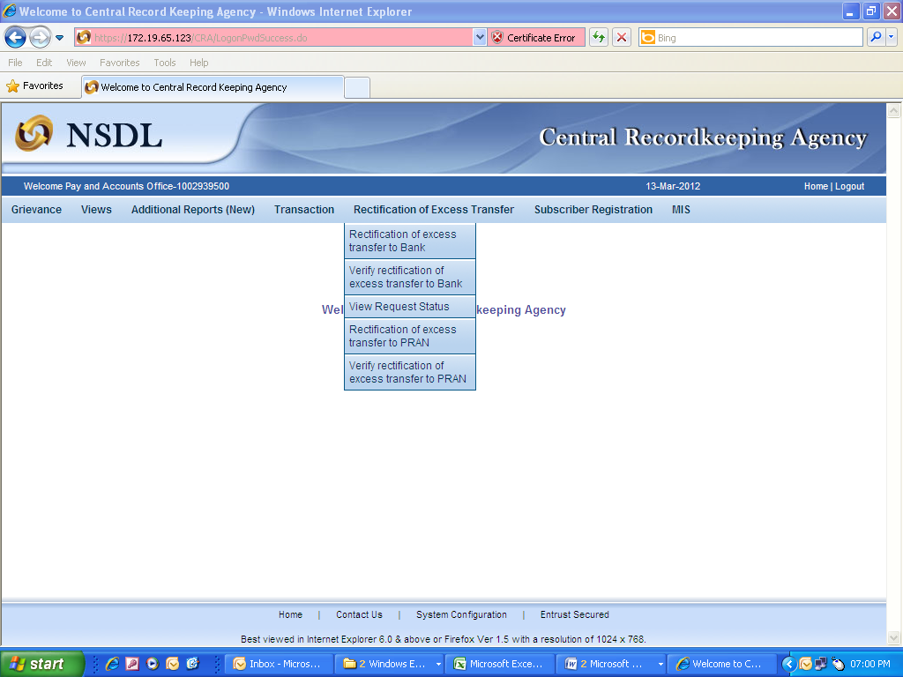
(Figure 11)

User will be shown the Welcome page of this menu. A summary containing information relevant to the menu has been provided in the Welcome page. Please refer Figure 12.

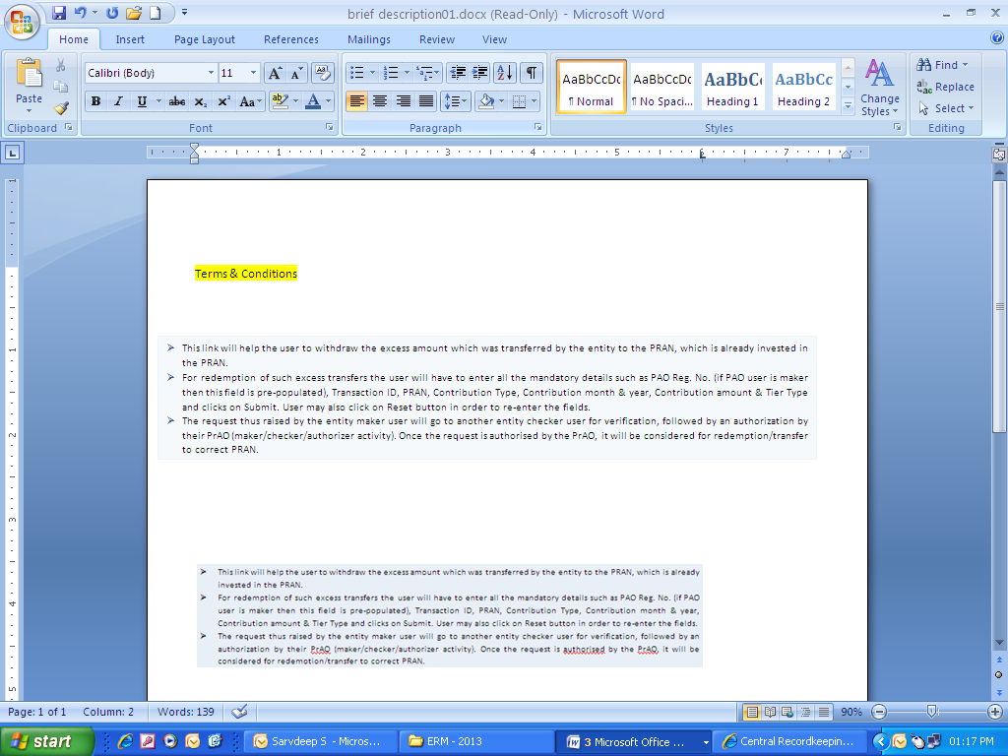
(Figure 12)

User will click the ‘Continue’ button to capture the request.

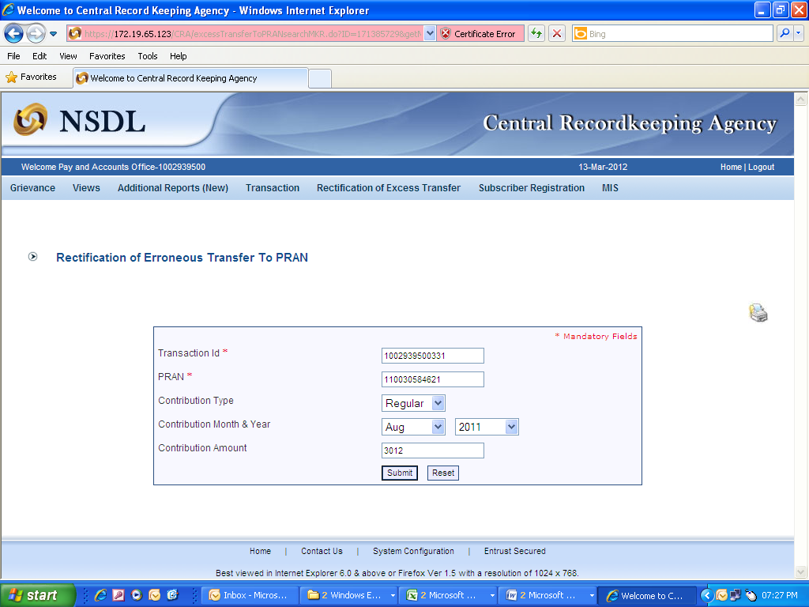
(Figure 13)

User will provide the required details. It is mandatory to provide ‘Transaction ID’ and PRAN. User can also provide the additional details such as Contribution type, Contribution Month and Year and the amount which has been credited to the subscriber. If the PRAN is not uploaded in the Transaction ID, CRA system will show as ‘No Record Found’. Please refer Figure 13.

Once User clicks the submit button, following screen will be shown to the User. Please refer Figure 14.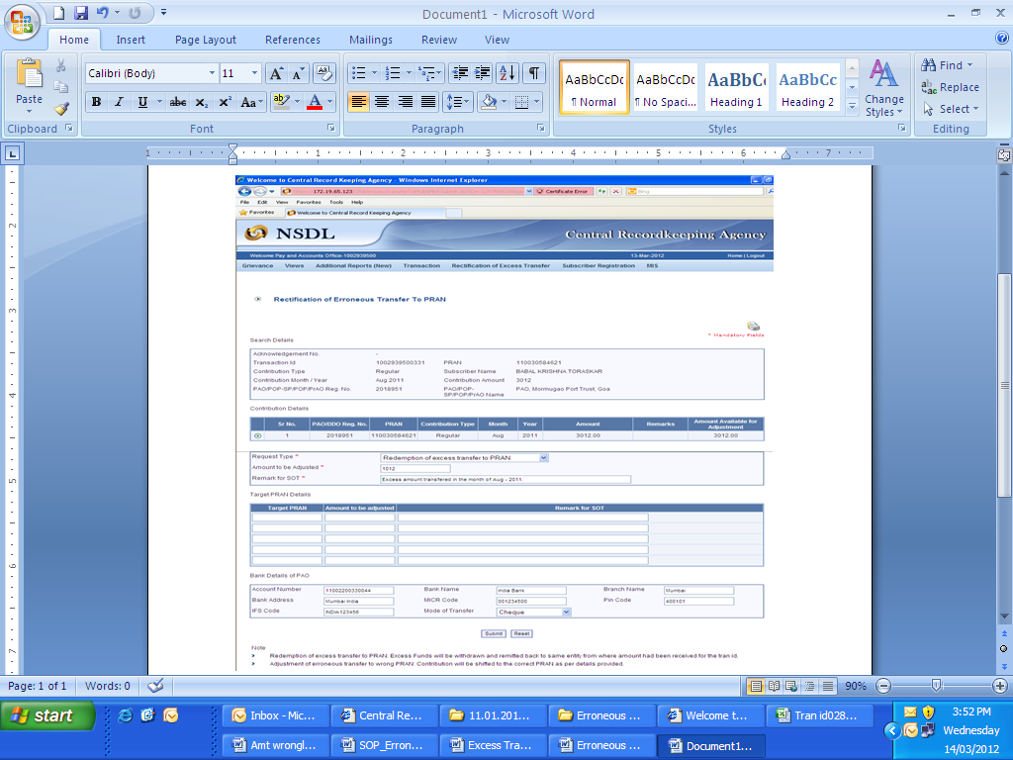
(Figure 14)

User will be shown all the contributions uploaded for the PRAN based on the search criteria. User has to choose the records where rectification is required. User will provide the following;

- Amount to be Adjusted: PAO User will provide the amount which is to be debited from the selected record. This particular amount will be debited from the subscriber account and will be paid to the PAO.

- Remarks for Transaction Statement (TS): PAO User will provide the appropriate remark in this field for subscriber’s TS. This remark will be shown in the subscriber’s TS with the debit entry of the ‘Amount to be Adjusted’.

- Bank Details: User will have to provide the Bank Details such as Account Number, Account Name, Branch Name, IFS Code, Mode of Transfer, MICR (MICR code is mandatory only in case ‘Type of Transfer’ selected as ‘Cheque’) etc. User should provide the Bank Details carefully as amount will be remitted to this Bank account. There will be certain validations while capturing the request such as ‘If the MICR is less than nine digits, message will be shown to the User ‘MICR should be of nine digits’. Same validation is there for IFS code. If the IFSC is less than 11 digits, message will be shown to the User ‘IFSC should be of 11 digits’

After providing the mandatory details, when PAO clicks the submit button, User will be shown the confirmation page as below. Please refer Figure 15.
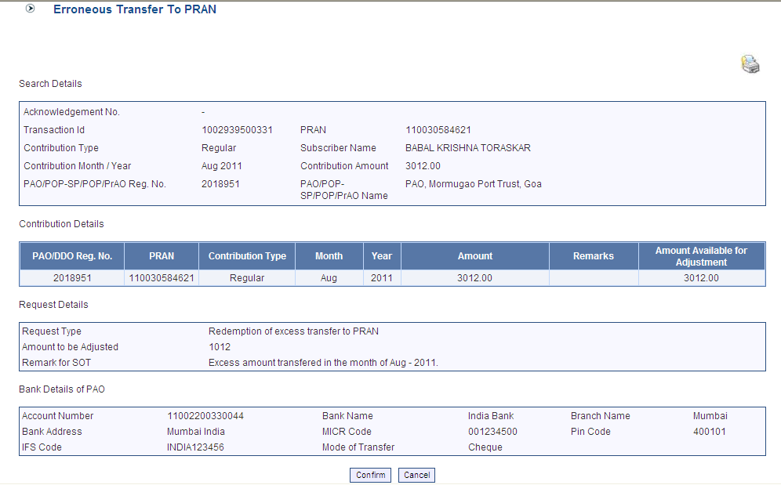
(Figure 15)

User will click on the Confirm button and Acknowledgement ID will be provided to the User. User should note down the Acknowledgment number for tracking the status of the request. Please refer Figure 16.

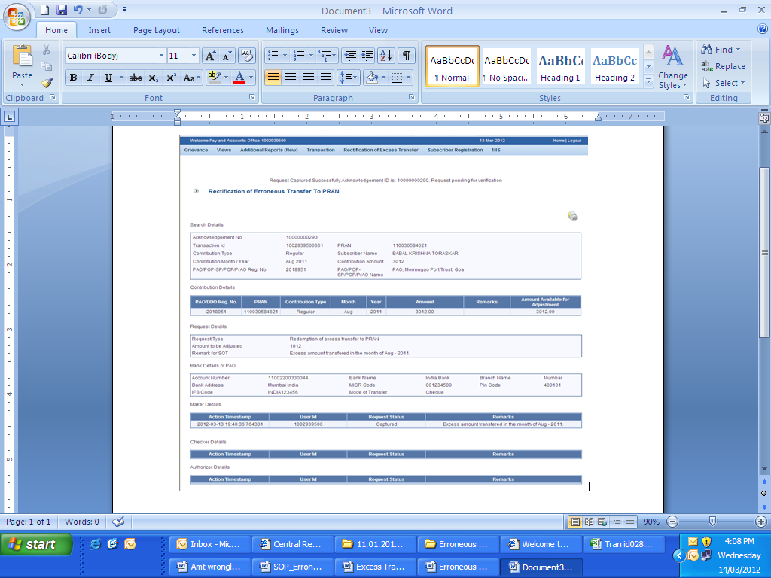
(Figure 16)

Request will be available to 2nd level PAO User to verify the rectification of excess transfer to PRAN.

Verification of Request

Another User will login into the CRA site using the second User ID and I-Pin. Once User logs into the site, User will click on the sub-menu ‘Verify Rectification of Erroneous Transfer to subscriber’. Please refer Figure 17.
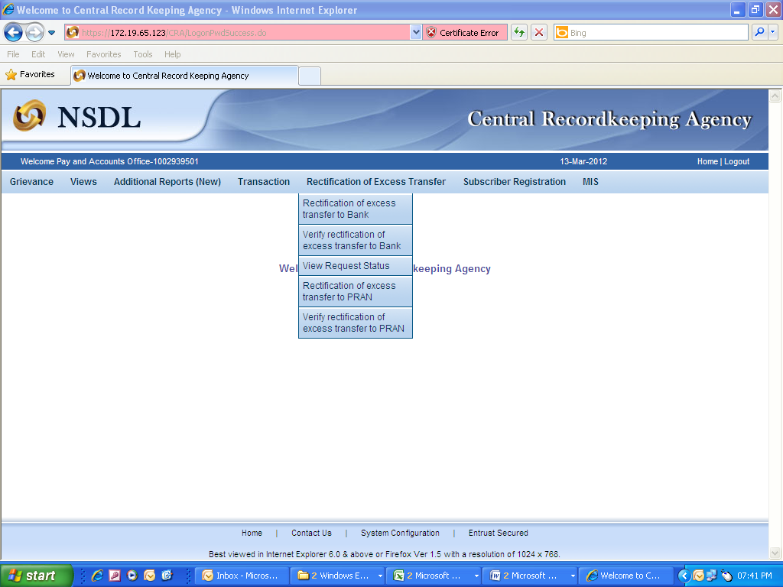
(Figure 17)

User will provide the PRAN/Acknowledgement ID and select the ‘Request Type’ in the search screen. User can also search the request by providing the ‘Date Range’. Please refer Figure 18.

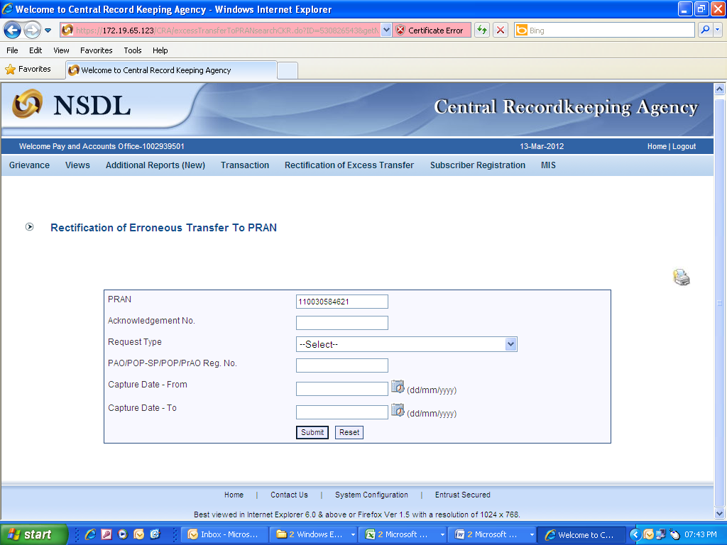
(Figure 18)

Once User provides the search fields, Acknowledgment ID hyperlink will be provided to the User. Please refer Figure 19.

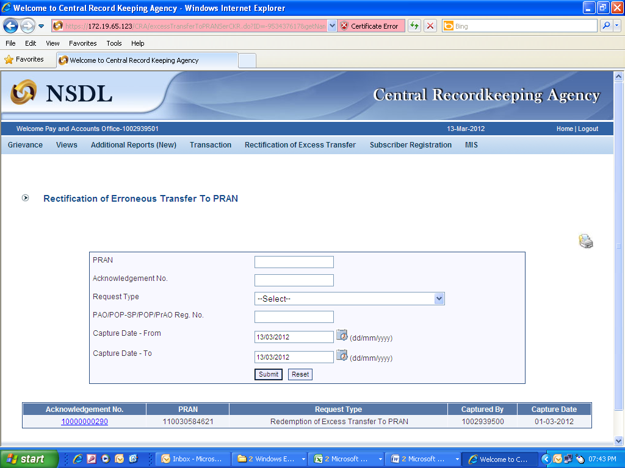
(Figure 19)

Once User clicks the hyperlink, rectification details will be shown to the User. User has the option to ‘Accept’ or ‘Reject’ the request. User can also provide the remarks in ‘remarks’ field for their reference while processing the request. Please refer Figure 20.

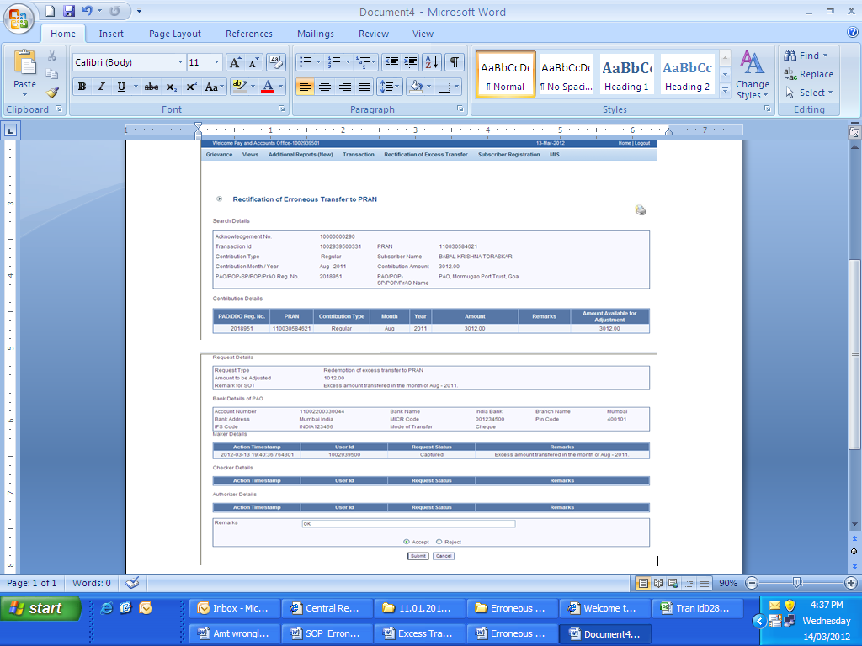
(Figure 20)

When the User submits the request, ‘Request Verified Successfully, Acknowledgement ID is 100XXXXXX Pending for authorization’ message will appear. Kindly note, if the PrAO User rejects the request, PAO User has to capture the fresh request for rectification, if needed. Please refer Figure 21.

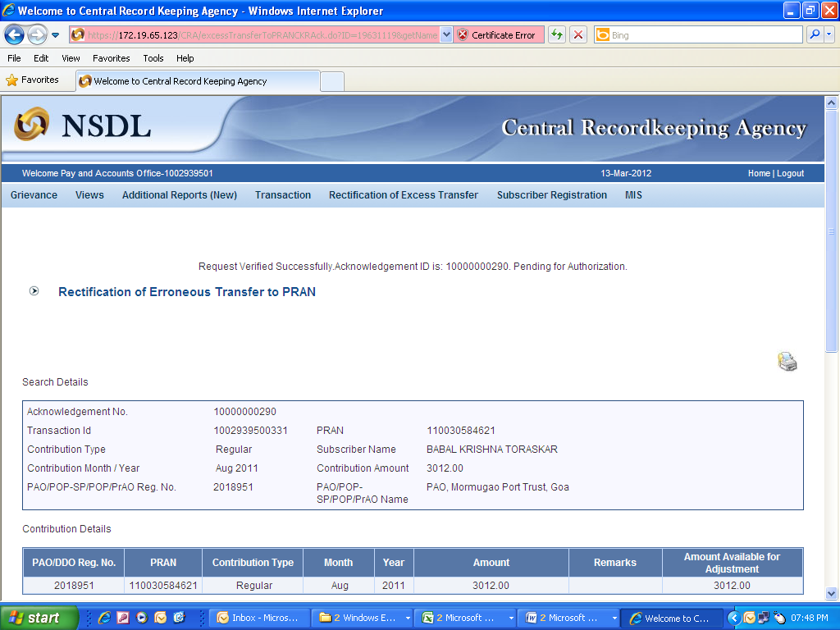
(Figure 21)

Once request is authorized by PrAO, the units credited in the subscriber account (equivalent to the contribution amount credited) erroneously would be redeemed. Amount (in Indian Rupees) equal to the initial investment would be credited back to the PAO and excess realized (if any) would be credited to the Investor’s Awareness Account maintained with the Trustee Bank. For example, PAO X had remitted Rs. 55,000/- instead of Rs. 5,500/- inadvertently in the subscribers PRAN - 110056XXXXXX on March 22, 2009. Let us say, as per NAV Rs. 10/-, 5,500 units were created for Rs. 55,000/- in the subscriber’s account. On February 15, 2012, PAO requested for refund of excess transferred amount to a PRAN (Rs. 49,500/-) as PAO/PrAO have identified the excess remittance which has been credited in subscribers account. PrAO will authorise the request (say on February 20, 2012) and balance units (5,500 units - 550 units of subscriber = 4,950 units) will be redeemed on February 21, 2012. If the NAV is Rs. 13.50/-, amount Rs. 66,825/- (4,950 units X 13.50) will be transferred to the withdrawal account. Trustee Bank will transfer the withdrawn amount (to the extent of Rs.49,500) to the PAO’s Bank account, remaining Rs.17,325 (Rs.66,825-Rs.49,500) will be transferred to the Investor Awareness Account.

Authorisation of Request

PrAO User will be able to view the request verified by the PAO. User has to click the menu ‘Error Rectification Module’ and sub-menu ‘Authorise rectification of Erroneous Transfer to subscriber’. Please refer Figure 21.1.

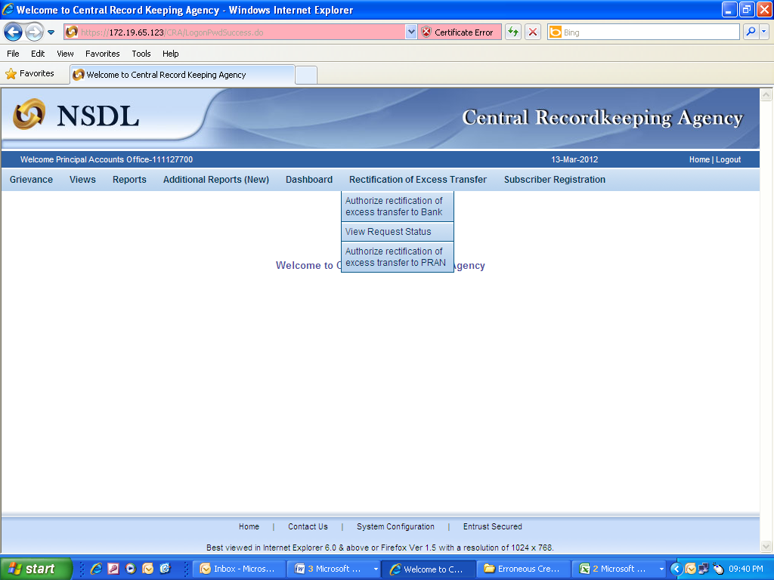
(Figure 21.1)

Search screen will be provided to the PrAO User where User has to provide the PRAN/Acknowledgement ID and select the ‘Request Type’. Request can also be searched by using the ‘Date Range’. Hyperlink will be provided to the User. Please refer Figure 21.2.

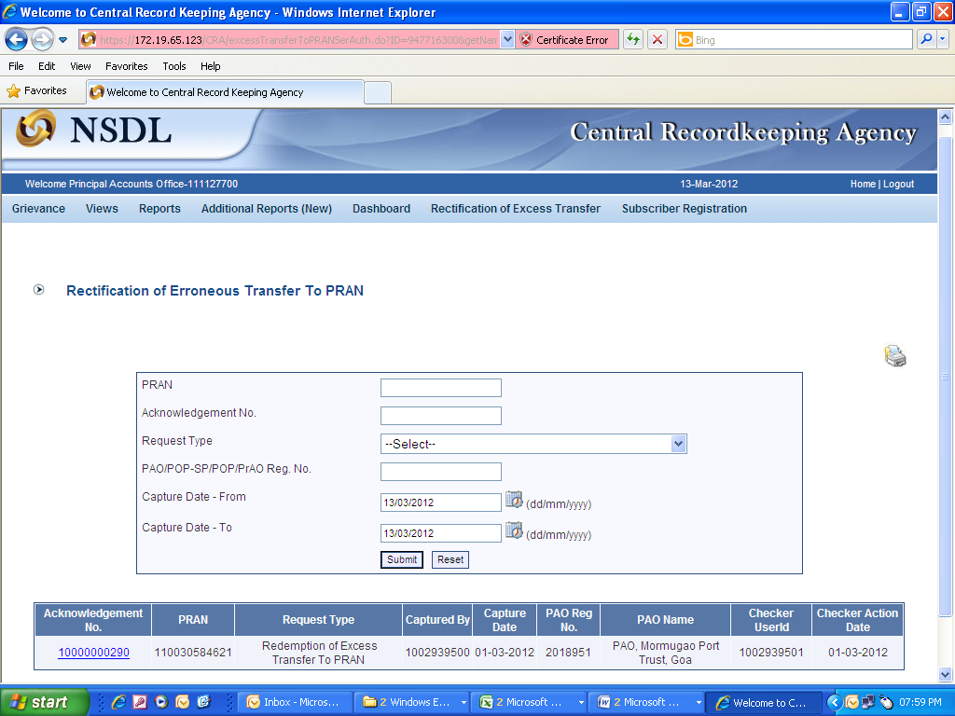
(Figure 21.2)

Once PrAO User clicks the hyperlink, rectification details will be shown to the User. PrAO has to check the details verified by the PAO. PAO should provide offline erroneous credit details to PrAO so that PrAO User can authorise the details in CRA system. PrAO User should check all the details entered by the PAO Users based on the offline details received from the PAO such as Source PRAN, amount to be debited from source PRAN and Payment to be received in the Bank account etc. User has the option to ‘Accept’ or ‘Reject’ the request. Kindly note, if the request is rejected by the PrAO User, PAO User has to capture the fresh request for rectification, if needed. PrAO User can also provide the remarks in ‘remarks field for their reference while processing/rejecting the request. Please refer Figure 21.3

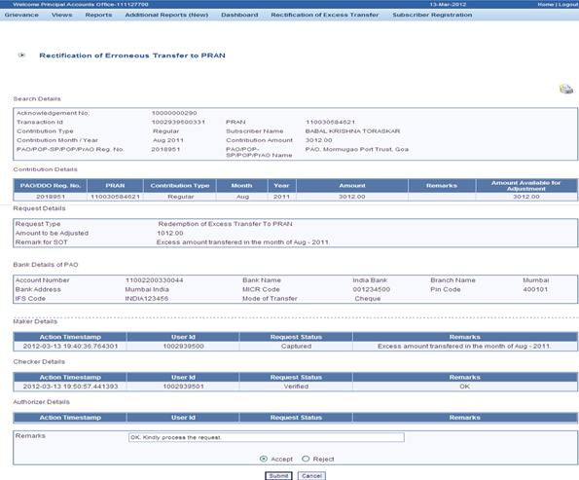
(Figure 21.3 )

When the PrAO User submits the request, ‘Request Authorised Successfully, Acknowledgement ID is 100XXXXXX’ message will appear. Please refer Figure 21.4.

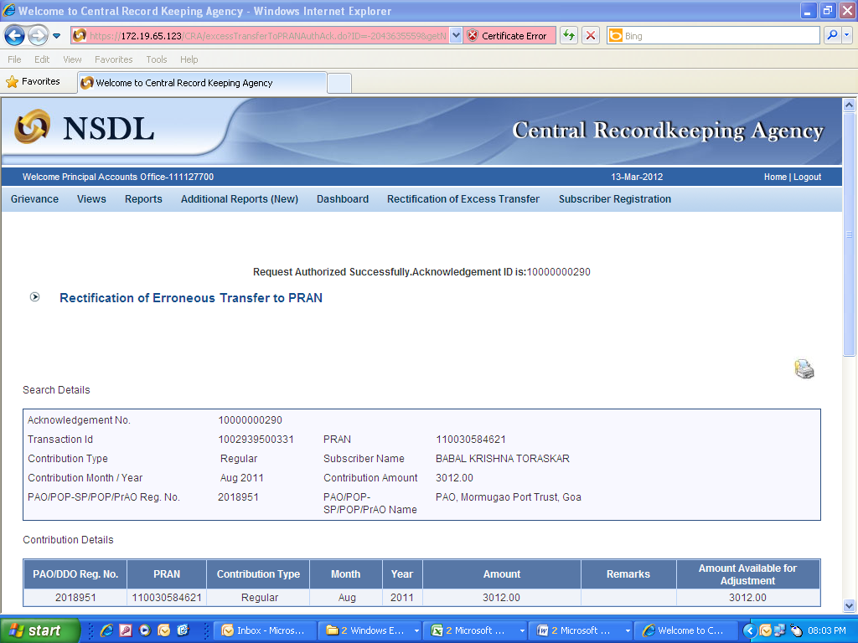
(Figure 21.4)

CRA will process the request which has been authorized by the PrAO. CRA will redeem the units and transfer the funds to the PAO account (provided at the time of request) on T+3 basis.

3 (c). Transfer to PRAN 1 instead of PRAN 2

In some cases, PAO has inadvertently transferred an amount to a PRAN 1 instead of PRAN 2. Accordingly units have been credited in the PRAN 1. As the amount is already credited to PRAN 1 (i.e. file is matched and booked), correction file cannot be uploaded by the PAO. In such cases, PAO has to put the request for rectification of entry in ‘Error Rectification Module’. Following are the validations built in the system:

- Both the PRANs (i.e. Source as well as Target) should belong to the sector of the PAO.

- PAO can capture the request for only that record which has been uploaded by it.

- Unless and until the request (captured earlier) is verified for a PRAN for the specific entry, PAO will not be able to capture a fresh entry for the same. For example, PAO has captured the request for withdrawal of regular credit of April’12. Unless this request is effectively completed, PAO will not be able to capture any other request for withdrawal of credit pertaining to April 2012 for this particular subscriber.

- PAO can capture maximum of five target PRANs in a request.

* In case, the subscriber’s scheme ratio is identical (at the time of erroneous credit as well as at the time of rectification) then equivalent units will be transferred from the source PRAN to the target PRAN.
Illustration: PAO X had remitted in excess Rs. 2,000/- in ‘PRAN 1’ inadvertently, instead of ‘PRAN 2’ on April 22, 2008. Based on NAV of Rs. 10/-, 200 units were created for Rs. 2,000/- and credited to PRAN 1. On February 15, 2012, PAO X has requested for rectification of incorrect credit in PRAN 1 and transfer of investment to PRAN 2. After PrAO authorizes the request for incorrect remittance of Rs. 2000/-, 200 units will be debited from the source PRAN and credited to the target PRAN at the End of the Day.

** In case, where subscriber’s scheme ratio is not identical (at the time of erroneous credit and at the time of rectification) then units worth of excess transferred amount will be redeemed from the source PRAN. Further, the redeemed amount will be re-invested as per the scheme ratio of target PRAN.
Illustration: PAO X had remitted in excess Rs. 3,000/- in ‘PRAN 1’ inadvertently instead of ‘PRAN 2’ on March 1, 2013. Based on NAV of Rs. 10/- of ‘SBI scheme -G’, 300 units were created for Rs. 3,000/- and credited to PRAN 1. After PAO has identified, PAO captures and verifies the rectification request on July 2, 2013 and PrAO authorises the request on July 4, 2013. Based on the NAV (Rs. 12) of July 4, 2013, 250 units will be redeemed from the PRAN 1. The redeemed amount will be re-invested in the target PRAN as per the settlement cycle.

Capturing of Request

Once PAO logs into the CRA site, there is a menu of ‘Error Rectification Module’. User will click the sub-menu ‘Rectification of Erroneous Transfer to subscriber’. Please refer Figure 22.
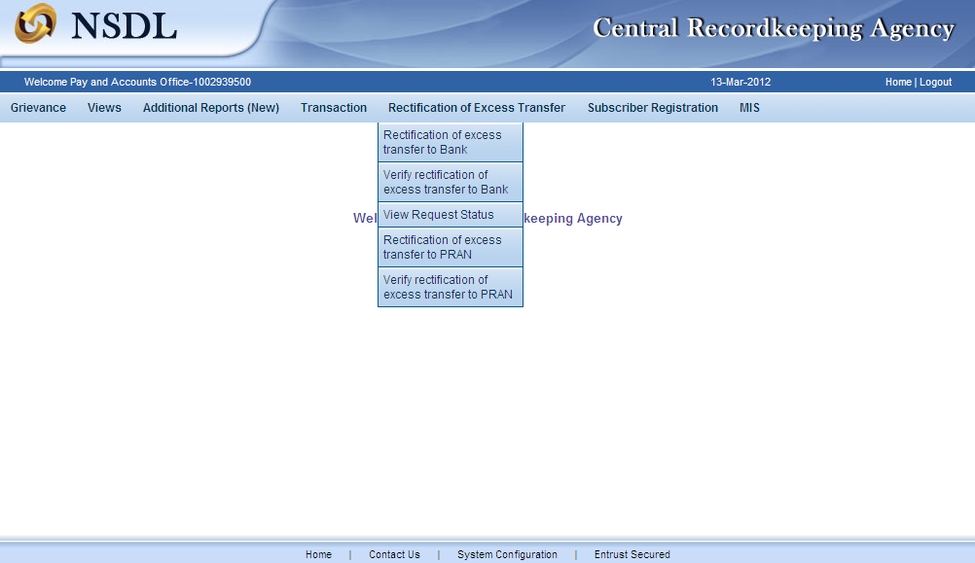
(Figure 22)

User will be shown the Welcome page of this menu. A summary containing information relevant to the menu has been provided in the Welcome page. Please refer Figure 23.

(Figure 23)

User has to click the ‘Continue’ button to capture the request.

(Figure 24)

User has to provide the required detail in the relevant fields. It is mandatory to provide ‘Transaction ID’ and PRAN (which has received incorrect credit). User can also provide the additional details such as Contribution type, Contribution Month and Year and the amount which has been credited to the subscriber. If the PRAN is not part of the Transaction ID, a message will be shown as ‘No Record Found’. Please refer Figure 24.

Once User clicks the submit button, following screen will be shown to the User. Please refer Figure 25.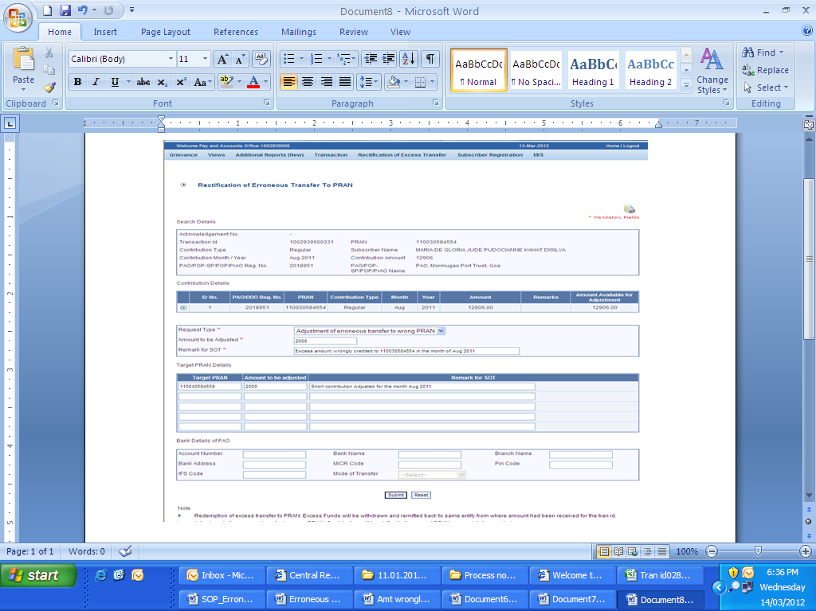
(Figure 25)

User will be shown all the contributions uploaded for the PRAN based on the search criteria. User will choose the records where rectification is required. User will provide following details:

- Target PRAN: PAO User will provide the PRANs where equivalent units of amount will be credited.
- Amount to be Adjusted: PAO User will provide the amount which is to be debited from the selected record. This particular amount will be debited from the Source PRAN (subscriber account) and will be credited to the Target PRAN.
- Remarks for TS: PAO User will provide the appropriate remark in this field for subscriber’s TS. This remark will be shown in the subscriber’s SOT with the credit entry of the ‘Amount to be Adjusted’.
After providing the mandatory details, when PAO User clicks the submit button, User will be shown the confirmation page as below. Please refer Figure 26.

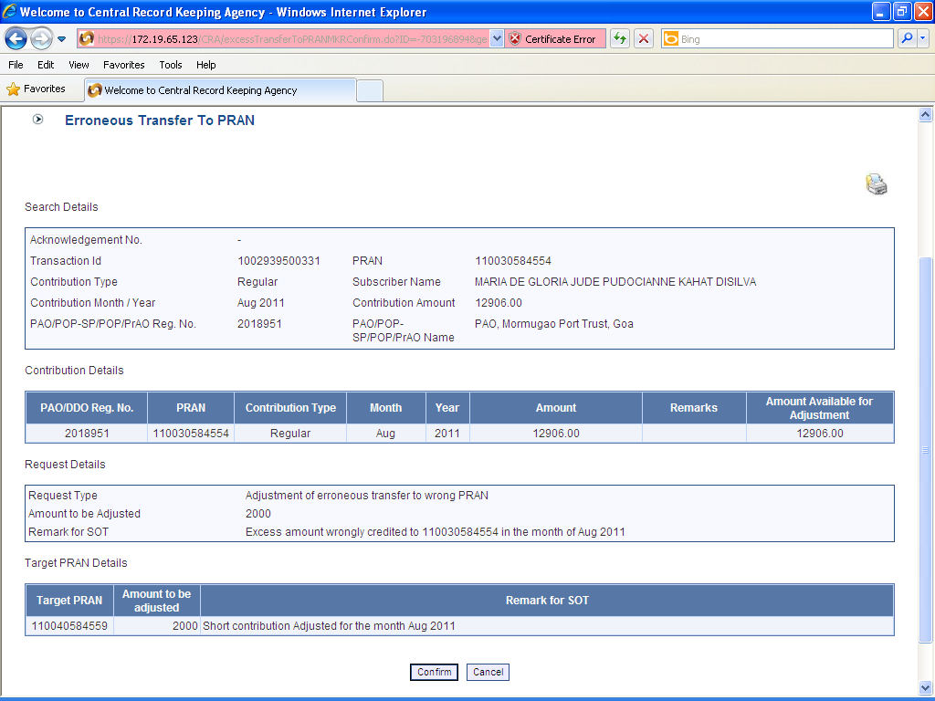
(Figure 26)

User should check all the details and then click on the ‘Confirm’ button. Acknowledgement ID will be generated in the CRA system and a message “Request captured successfully, Acknowledgement ID is 100XXXXXX. Request pending for verification” will be shown to the User. User should note down the Acknowledgment number for tracking the status of the request. Please refer Figure 27.

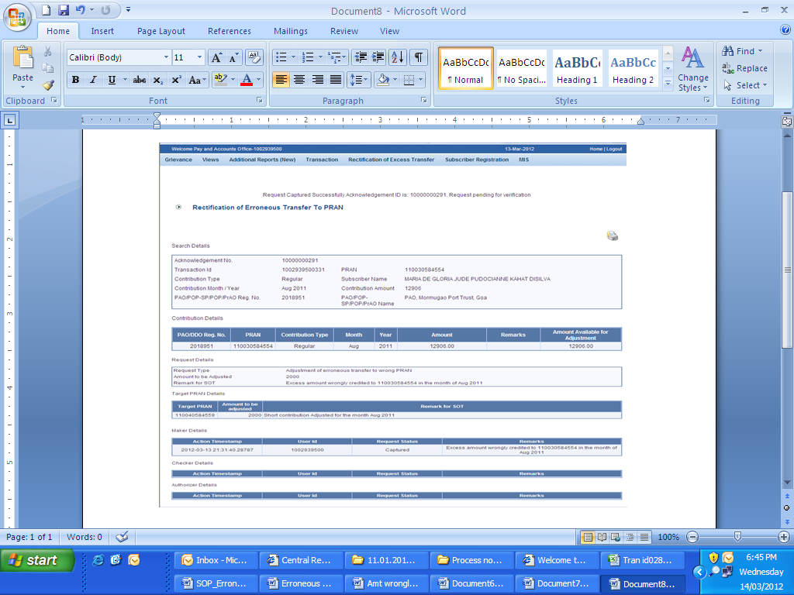
(Figure 27)

Request will be available to 2nd level PAO User to verify the rectification of excess transfer to PRAN 1 instead of PRAN 2.

Verification of Request

Another PAO User will login into the CRA website using the second User ID and I-Pin. Once User login into the website, User has to click on the sub-menu ‘Verify Rectification of Erroneous Transfer to subscriber’. Please refer Figure 28.

(Figure 28)

All pending requests will be shown to the User after clicking the ‘Verify Rectification of Erroneous Transfer to subscriber’. User can search for a particular request by providing the Acknowledgement ID and ‘Request Type’. User can also search the request by providing the ‘Date Range’. Once User provides the search fields, Acknowledgment IDs (hyperlink) will be provided to the User. Please refer Figure 29.

(Figure 29)

Once User provides the search fields, hyperlink will be provided to the User. Please refer Figure 30.
(Figure 30)

Once User clicks the hyperlink, rectification capture details will be shown to the User. User has the option to ‘Accept’ or ‘Reject’ the request. User can also provide the remarks in ‘remarks’ field for their reference while processing the request. Please refer Figure 31.
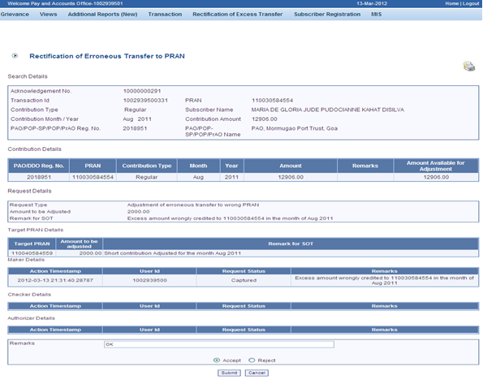
(Figure 31)

When the User submits the request, ‘Request Verified Successfully, Acknowledgement ID is 100XXXXXX Pending for authorization’ message will be shown. Kindly note, if the PrAO User rejects the request, PAO User has to capture the fresh request for rectification, if needed. Please refer Figure 32.
(Figure 32)

Once request is authorized by PrAO, units will be debited from the source PRAN and credit in the Target PRAN(s)

Authorisation of Request

PrAO User will be able to view the request verified by the PAO in his/her log-in. User has to click the menu ‘Error Rectification Module’ and sub-menu ‘Authorise rectification of Erroneous Transfer to subscriber’. Please refer Figure 32.1.

(Figure 32.1)

All the pending requests will be shown to the User after clicking the ‘Authorise Rectification of incorrect credit in a PRAN’. Search screen will be provided to the PrAO User where User has to provide the PRAN/Acknowledgement ID and select the ‘Request Type’. Request can also be searched by using the ‘Date Range’. Hyperlink will be provided to the User. Please refer Figure 32.2.

(Figure 32.2)

Once PrAO User clicks the hyperlink, rectification details will be shown to the User. PrAO has to check the details verified by the PAO. PAO should provide offline details to PrAO so that PrAO User can authorise the details in CRA system. PrAO User should check all the details entered by the PAO Users based on the offline details received from the PAO such as Source PRAN, Target PRANs, amount to be debited from source PRAN and amount to be credited in the target PRANs etc. User has the option to ‘Accept’ or ‘Reject’ the request. User can also provide the remarks in ‘remarks field for their reference while processing the request. Please refer Figure 32.3.

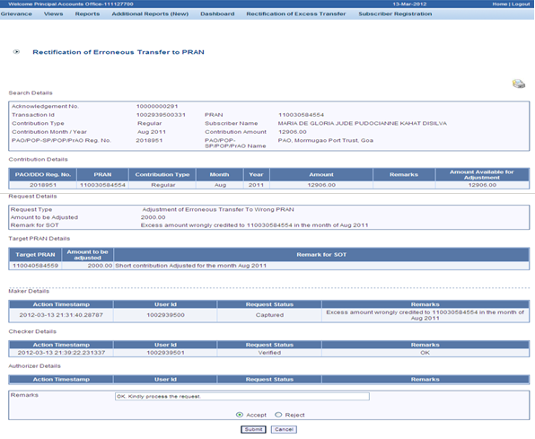
(Figure 32.3)

When the PrAO User submits the request, message ‘Request Authorised Successfully, Acknowledgement ID is 100XXXXXX’ will be shown. Please refer Figure 32.4.

(Figure 32.4)

CRA will process the request which has been authorized by the PrAO. CRA will redeem equivalent units from the source PRAN (PRAN 1) and credit to the target PRAN (PRAN 2).

3 (d). Non-NPS Subscriber withdrawal

This scenario consists of a situation wherein PAO has inadvertently committed the error by allotting the PRAN for Non-NPS subscriber and also transferred the amount in the CRA system. Now the amount needs to be withdrawn and given back to the PAO. For this, PAO is required to use the functionality of Non-NPS subscriber withdrawal. PAO will login into the CRA system and click the ‘Error Rectification Module’. A sub-menu will be provided for ‘Non-NPS subscriber withdrawal’. The procedures to be followed to process the withdrawal requests are given as under:

- Capturing of Request by PAO
- Verification of Request by PAO
- Authorisation of Request by PrAO

Before processing the request, certain validations will be performed such as:

- The PAO can capture such requests only for the subscribers associated with it.

- Request has to be authorized by the PrAO.

- All the units credited in the subscriber’s PRAN will be redeemed.

- If there are any contribution files pending to be matched for the subscriber, then the request for withdrawal of funds will be rejected at EOD. These pending SCFs may be corrected by the PAO to exclude the said PRAN. Subsequently, request for non-NPS withdrawal can be captured.

- Redeemed units will be transferred in the suspense account (subsequent to authorization of request by PrAO) and will be considered for the redemption in the next settlement cycle.

- Once request is processed in the CRA system, PRAN will be deactivated in the CRA system. No contribution will be allowed to be credited in the subscriber’s PRAN.

Capturing of Request

PAO will login into the CRA system (www.cra-nsdl.com) by using its User ID and I-PIN. Please refer Figure 33.

(Figure 33)

Once PAO login into the CRA site, ‘Error Rectification Module’ menu will be shown. User will click the sub-menu ‘Redemption of Non-NPS Contribution’. Please refer Figure 34.

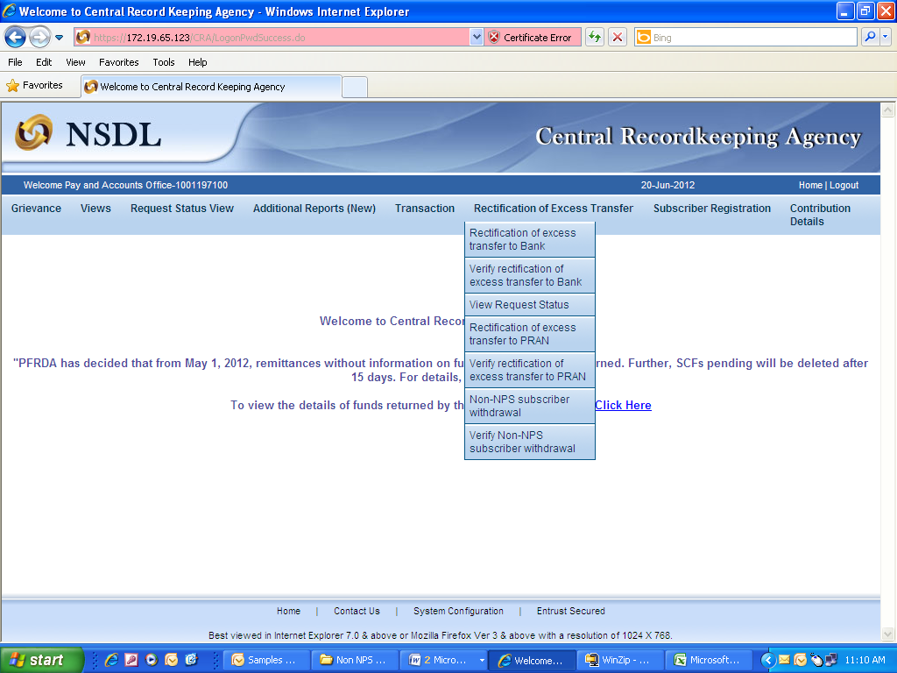
(Figure 34)

User has to provide the PRAN (which has got inadvertently covered under NPS) and click the submit button. Please refer Figure 35.

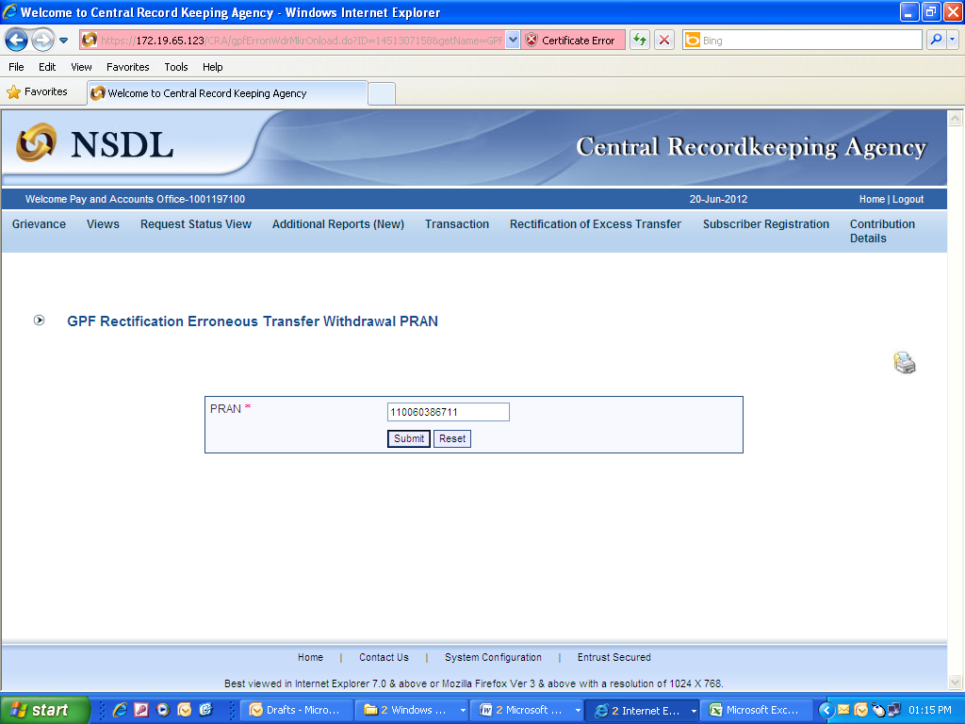
(Figure 35)

PAO has to provide the Bank details as ‘Bank Account Number, Bank Name, Bank Branch, IFS code, MICR Code etc’ where PAO requires Trustee Bank to remit back the funds. PAO also has to provide the remarks in ‘remarks’ field for their reference while processing the request. PAO should mention the Government Bank account which needs to be credited by the Trustee Bank. Please refer Figure 36.

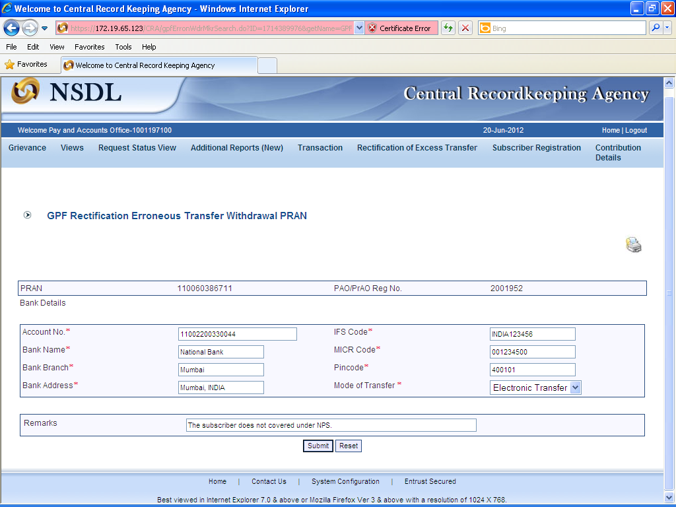
(Figure 36)

When User clicks the Submit button, confirmation page will be shown to the User as below. Please refer Figure 37.
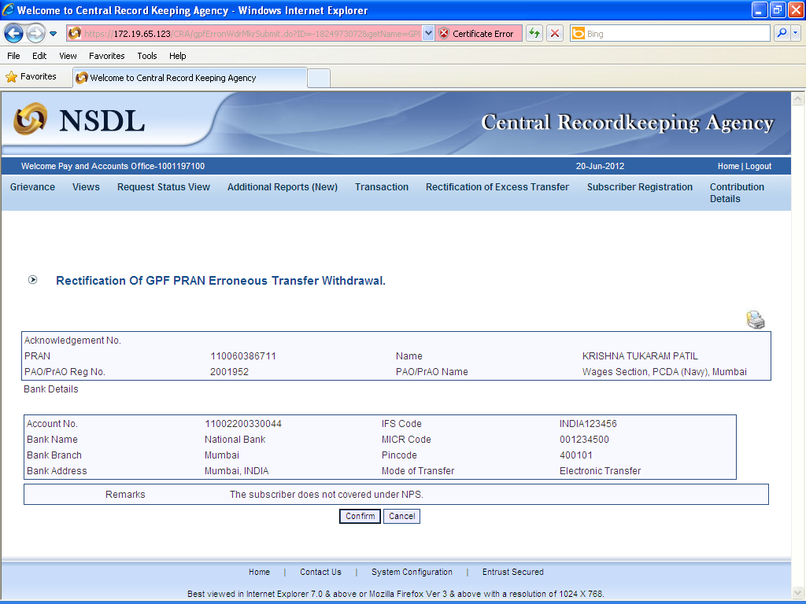
(Figure 37)

User has to click the ‘Confirm’ button to generate the Acknowledgement Number. Please refer Figure 38.

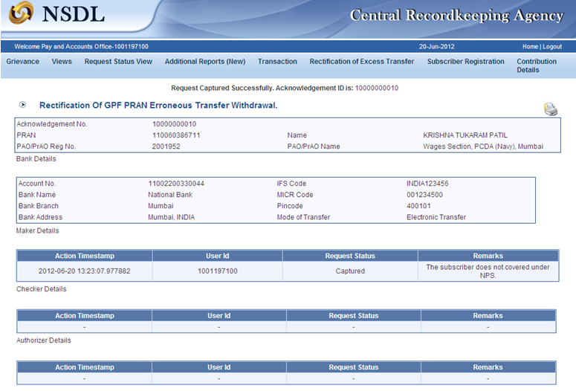
(Figure 38)

When the User confirms the request, a message ‘Request Captured Successfully, Acknowledgement ID is 100XXXXXX’ will be shown to the User. User should note down the Acknowledgment number for tracking the status of the request.

Verification of Request

Another User will login into the CRA site using the second User ID and I-PIN. Once User login into the site, User will click on the sub-menu ‘Verify Redemption of Non-NPS Contribution. Please refer Figure 39.

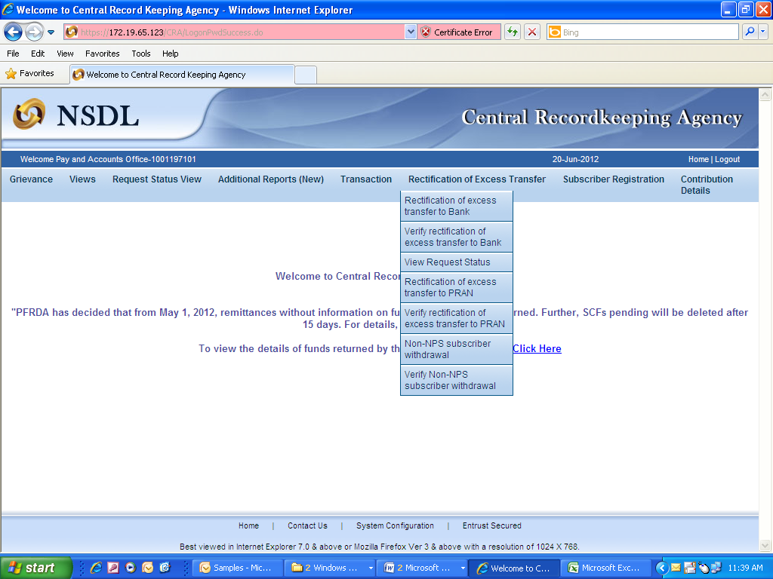
(Figure 39)

User will provide the required details (i.e. Acknowledgement Number or PRAN). User can also search the request by providing the ‘Date Range’. Please refer Figure 40.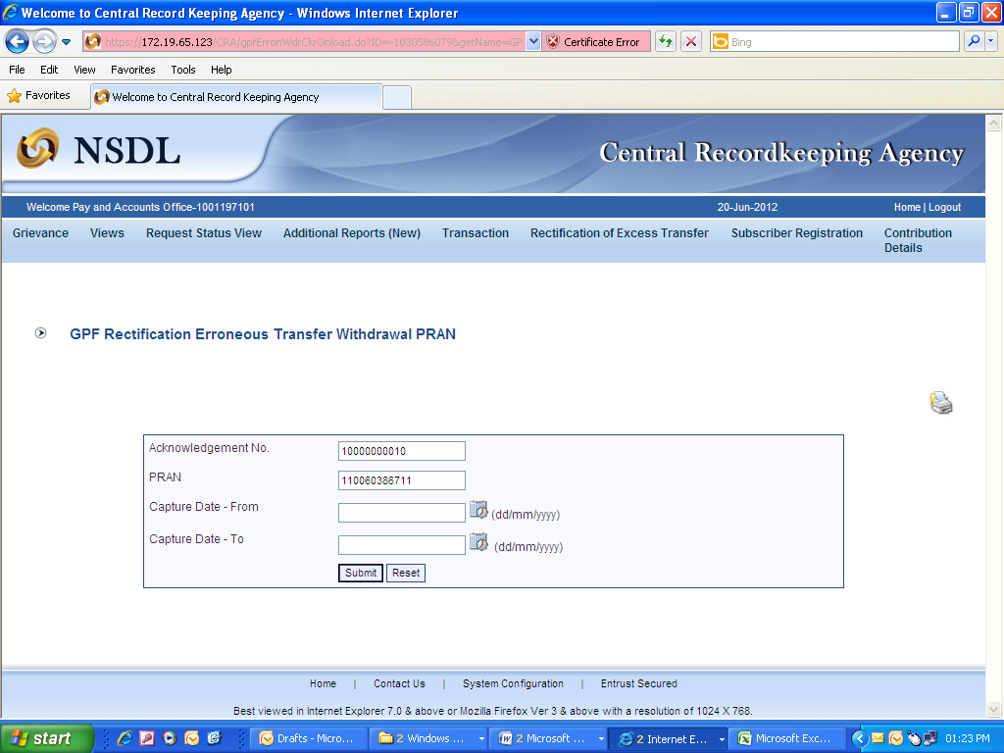
(Figure 40)

Once User provides the search fields, Acknowledgment IDs (hyperlink) will be provided to the User. Please refer Figure 41.
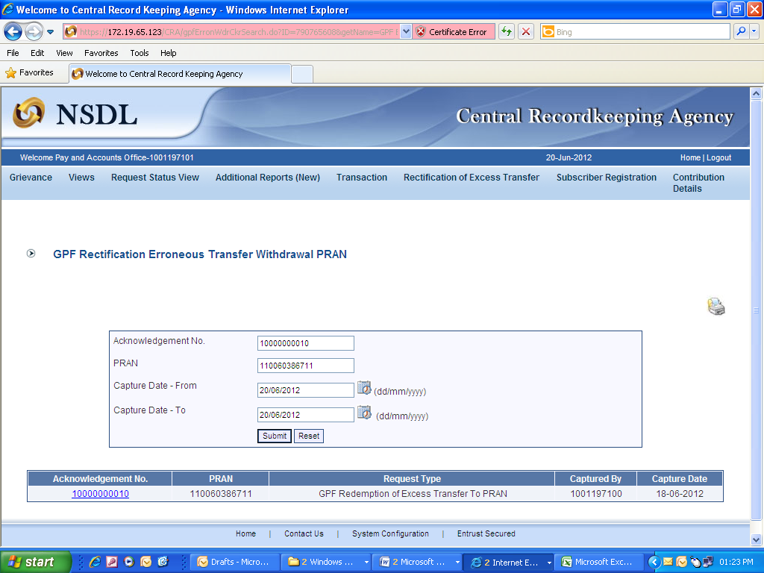
(Figure 41)

Once User clicks the hyperlink, Non-NPS Subscriber Withdrawal captured details will be shown to the User. User has the option to ‘Accept’ or ‘Reject’ the request. User can also provide the remarks in ‘remarks’ field for their reference while processing the request. Kindly note, if the second User rejects the request, request has to be captured afresh, if needed. Please refer Figure 42.

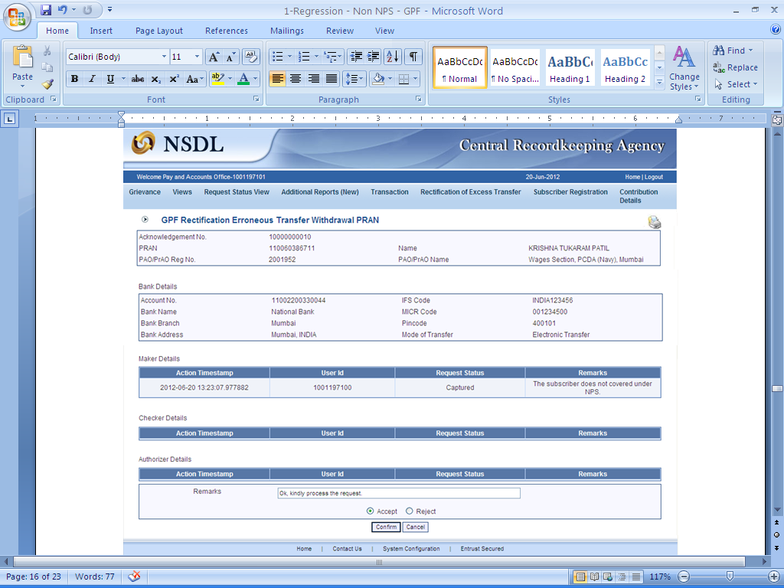
(Figure 42)

When the User confirms the request, ‘Request Verified Successfully, Acknowledgement ID is 100XXXXXX Pending for authorization’ message will be shown. Please refer Figure 43.

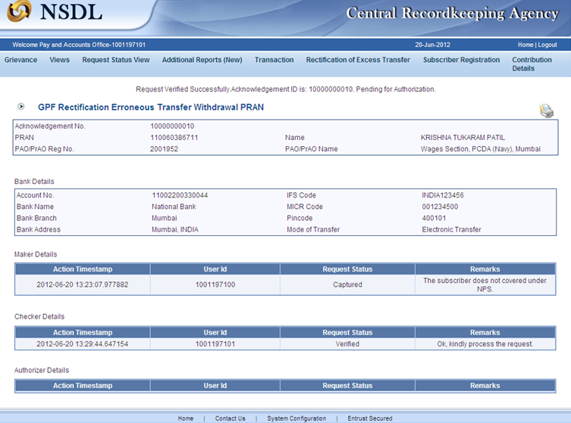
(Figure 43)

Once request is authorized by PrAO, units will be debited from the source PRAN. Trustee Bank will transfer the funds to the bank account provided at the time of capturing the request.

Authorisation of Request

PrAO User will be able to view the request captured and verified by the PAO. User will click the menu ‘Error Rectification Module’ and sub-menu ‘Authorise Redemption of non-NPS contribution’. Please refer Figure 43.1.

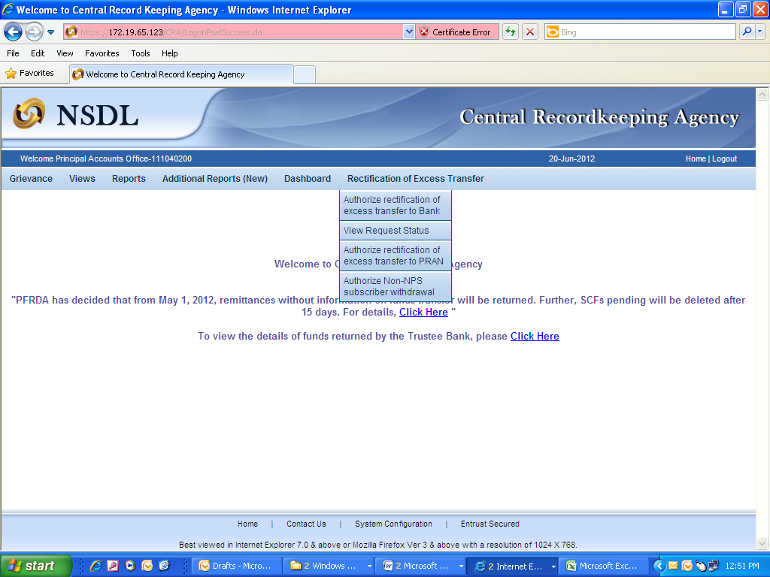
(Figure 43.1)

Search screen will be provided to the PrAO User where User has to provide the PRAN/Acknowledgement ID. Request can also be searched by using the ‘Date Range’. Please refer Figure 43.2.

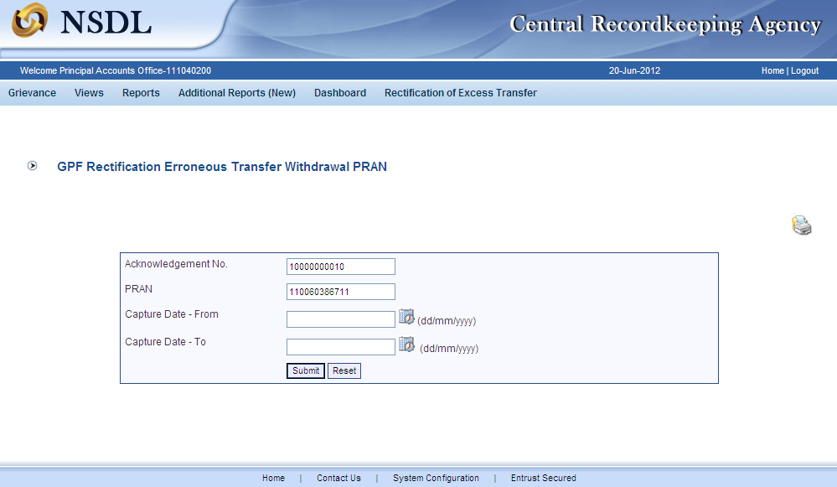
(Figure 43.2)

Once User provides the search fields, Acknowledgment IDs (hyperlink) will be provided to the User. Please refer Figure 43.3.

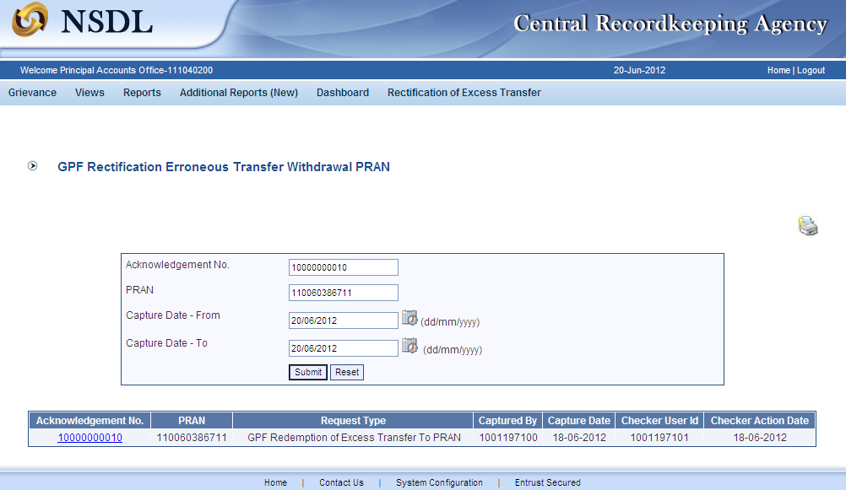
(Figure 43.3)

Once PrAO User clicks the hyperlink, rectification details will be shown to the User. PrAO has to check the details verified by the PAO. PAO should provide offline details to PrAO so that PrAO User can authorise the details in CRA system. PrAO User should check all the details entered by the PAO Users based on the offline details received from the PAO such as PRAN, Holding details to be redeemed, and Bank details where PAO requires Trustee Bank to remit back the funds etc. User has the option to ‘Accept’ or ‘Reject’ the request. User can also provide the remarks in ‘remarks field’ for their reference while processing the request. Please refer Figure 43.4.

Kindly note, if the PrAO User rejects the request, PAO User has to capture the fresh request for rectification, if needed.

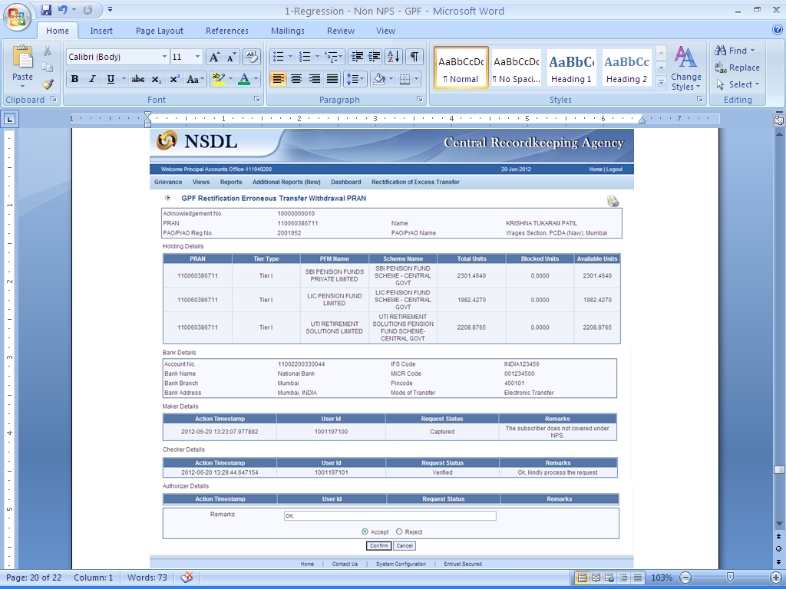
(Figure 43.4)

When the PrAO User submits the request, message ‘Request Authorised Successfully, Acknowledgement ID is 100XXXXXX’ will be shown. Please refer Figure 43.5.

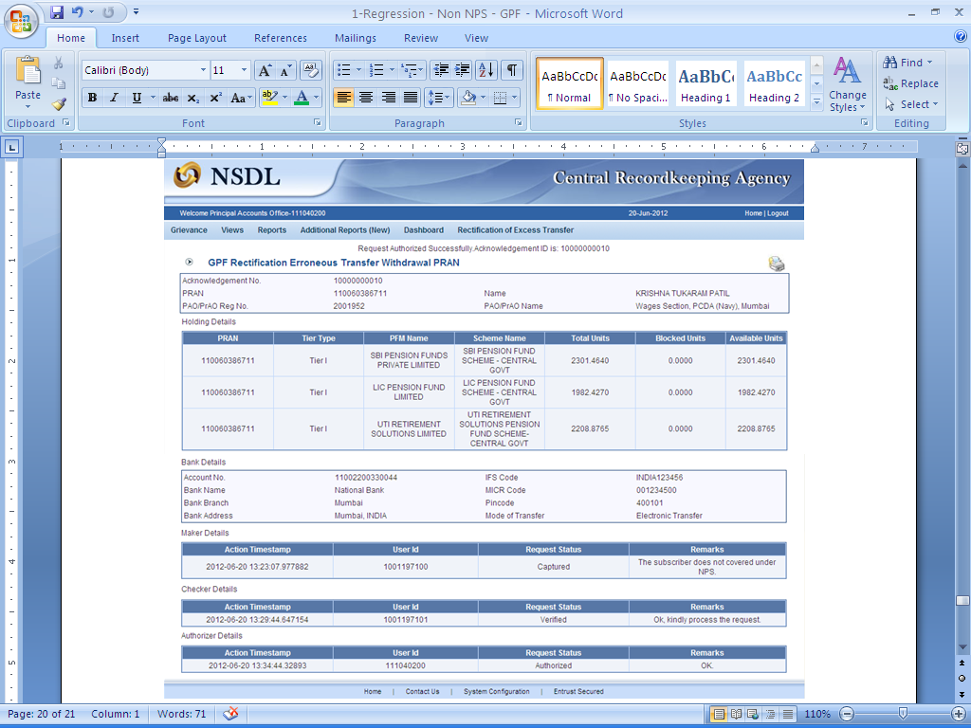
(Figure 43.5)

CRA will process the request which has been authorized by the PrAO. CRA will redeem all the units from the subscribers account. The redeemed units will be transferred in the suspense account and will be considered for the redemption in the next settlement cycle.Once request is processed in the CRA system, PRAN will be deactivated in the CRA system. No contribution will be allowed to be credited in the subscriber’s PRAN.

Views by PrAO

PrAO User will be able to view the status of request authorized by him/her. User has to click the menu ‘Error Rectification Module’ and sub-menu ‘View Request Status’. Please refer Figure 44.

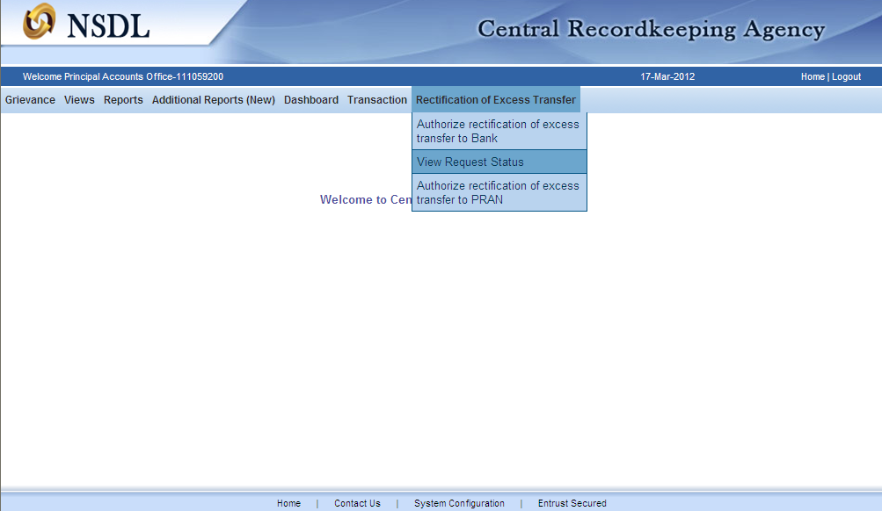
(Figure 44)

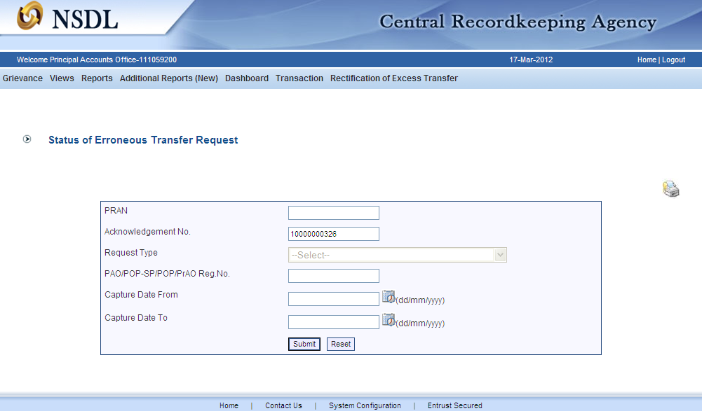
(Figure 45)

User can view the status of a particular request by providing the Acknowledgement ID. User can also search the request by providing the Request Type’, ‘PRAN’ or ‘Date Range’. Once User provides the search fields, Acknowledgment IDs (hyperlink) will be provided to the User. Please refer Figure 45 and 46.

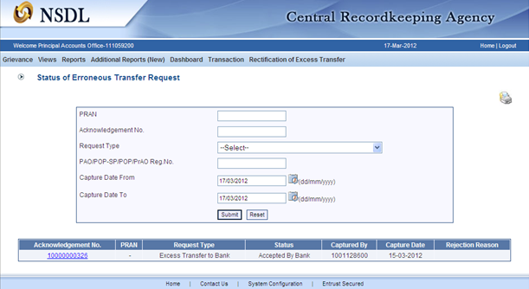
(Figure 46 )

Once User clicks the hyperlink, the details of specific request will be available for view. Please refer Figure 47.

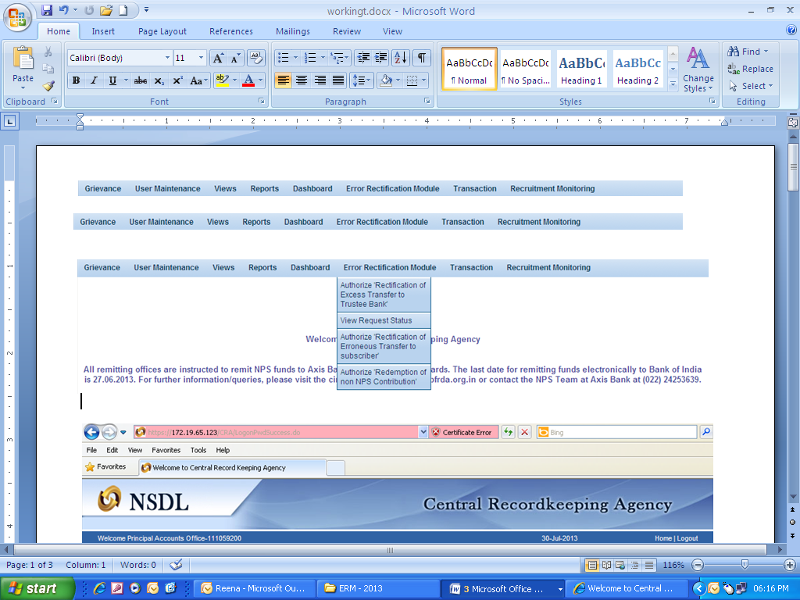
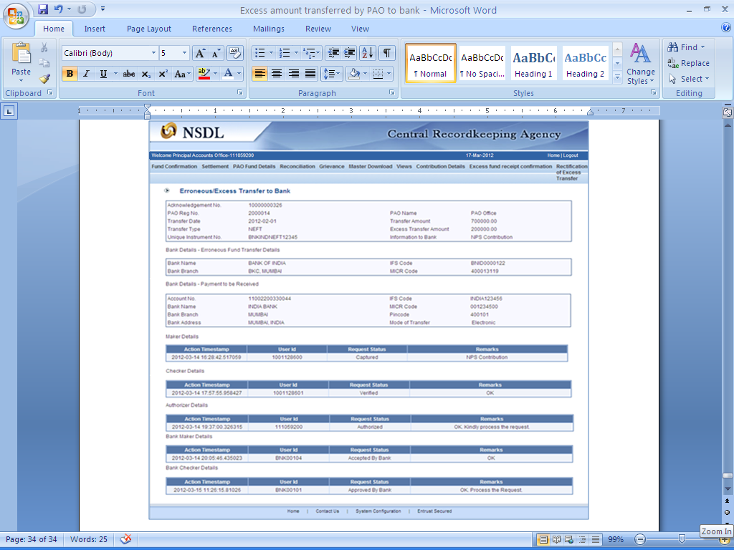
(Figure 47)

-------X-------X-------

Pool Account: Funds received by Trustee Bank, if not identified were being credited to a ‘Pool Account’ for the CG Sector.

