Operating Guidelines
for Corporates

Confirmation of Employees Registering
under eNPS

Introduction:

As advised by PFRDA, the eNPS platform is now available to the Corporate sector for online subscriber registration and contribution upload. The Corporate subscribers can register online under NPS once the online PAN verification by CRA and KYC authentication by the Banks are complete. The Corporates need to confirm the subscriber's association with it i.e., whether the subscriber is its employee.

This document provides the guidelines about the roles and responsibilities of Corporate with respect to subscriber registration under eNPS.

Creation of User IDs for Corporates:

The Corporates shall have ‘Digital Signature Certificate (DSC)’ based authentication in eNPS module to perform the operational activities related to subscriber registration and contribution upload. CRA will create the two User IDs for the Corporate for accessing the eNPS system. The Corporate is required to provide DSC details for these 'User IDs’.

The Corporate is required to submit the DSC details through Form CHO-N1-A supported by relevant screen shots of the DSC details. The DSC details can be accessed by following the link "<Internet Explorer> <Tools> <Internet Options> <Content> <Certificates>". On receipt of DSC details, CRA will create the two User IDs and map the DSC details to the same. Once the DSCs are mapped to the User IDs, Corporate will be able to access the eNPS and CRA system. The form CHO-N1-A can be freely downloaded from CRA website (www.npscra.nsdl.co.in).

Approving the online Subscriber Registration:

The Corporate subscriber shall register under eNPS by providing the relevant registration details and initial contribution amount (for complete process, please refer the "Steps to be followed" by the subscribers under eNPS). After successful submission of registration details and contribution, PRAN will be allotted to the subscriber online. On allotment of PRAN, the PAN details of the subscriber will be verified by CRA and KYC details will be verified by the Bank (which the subscriber has linked to his/her NPS account). Once PAN and KYC verification is completed, PRAN will be available to the concerned Corporate for online verification in the CRA system under the Corporate login. The Corporate is required to login and confirm the subscriber's association with it.

The steps to be followed by the Corporate for employee confirmation are as under:

Step 1:

The Corporate User will login to the CRA system using DSC based User IDs. On successful login, the User will select the option "Corporate Employee Confirmation" under menu "Subscriber Registration" as given in Figure 1 below:

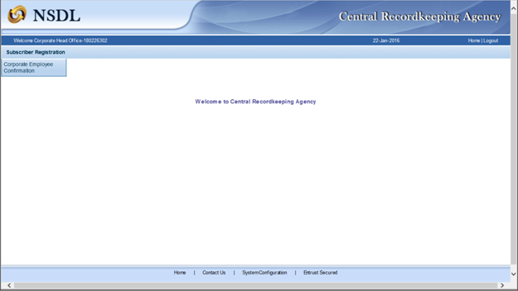
Figure 1

Step 2:

The User will enter necessary search criteria (as shown in Figure 2 below) to view the records to be verified. The search is based on PRAN, Acknowledgment No. or Date Range. However, the date range for the search criteria cannot be greater than 15 days.
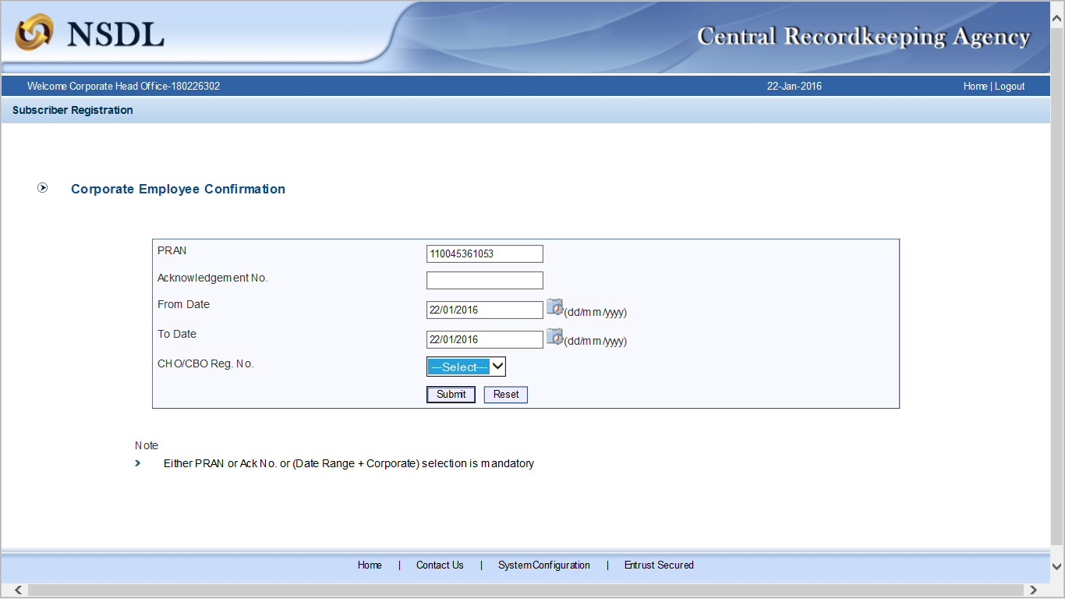
Figure 2

Step 3:

Based on the search criteria, the list of PRANs which are pending for confirmation under Corporate will be displayed to the User as shown in Figure 3 below.
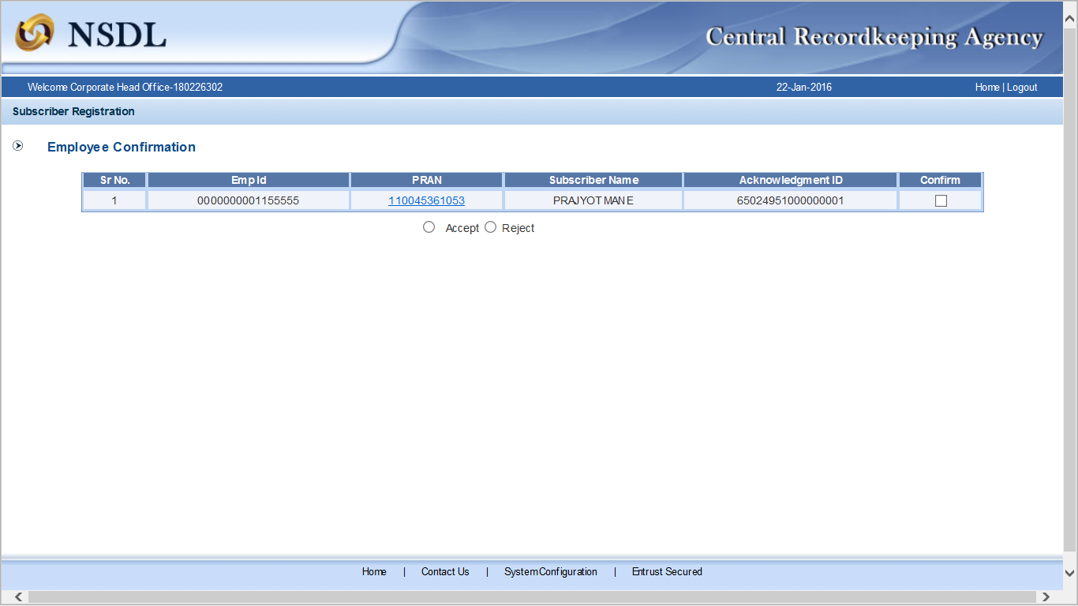
Figure 3

Step 4:

The User will click the hyperlink appearing on the PRAN for the respective record to be verified. Once the link is accessed, the subscriber details will be displayed to the User.

The User will verify the registration details provided by the subscriber under eNPS as shown in the Figure 4 below.

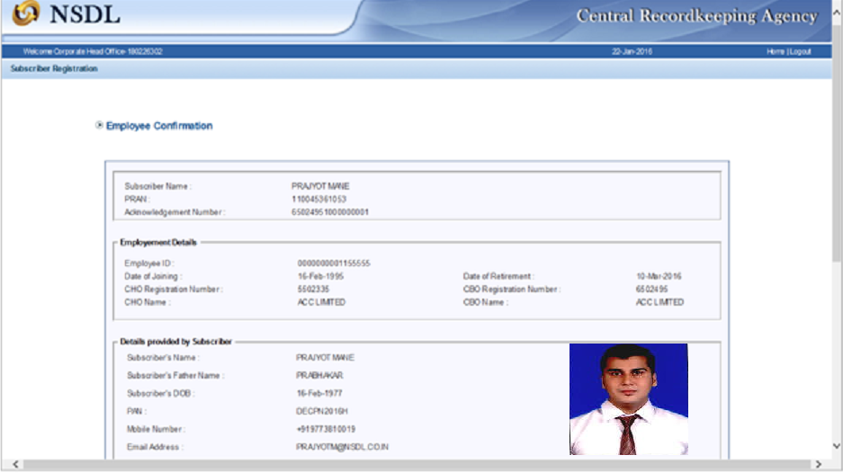
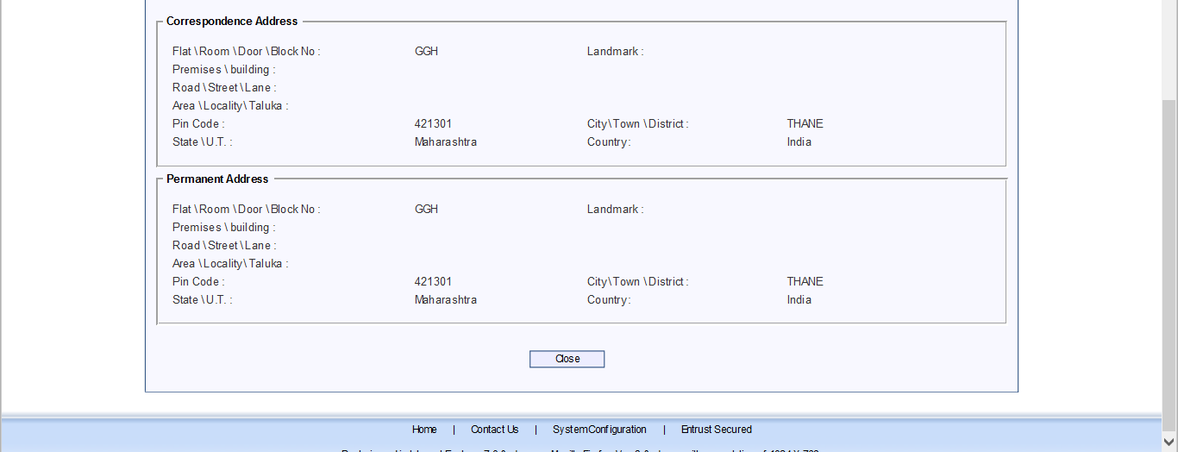
Figure 4

Step 5:

If the subscriber details are correct, the User will approve the registration/association of PRAN by clicking the ‘Accept’ button and declaration box as shown in Figure 5 below. In case of rejection, the User will click the 'Reject' button and will provide the reason for rejection.

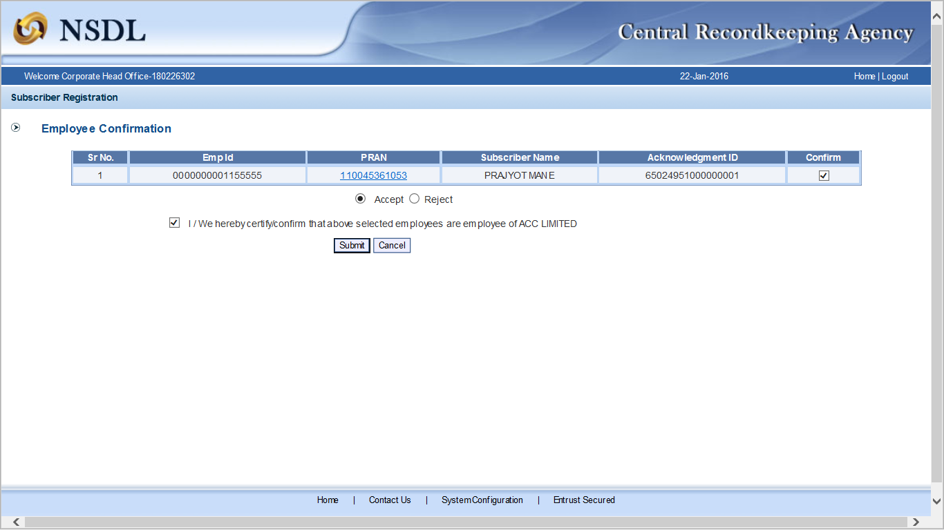
Figure 5

Step 6:

On successful acceptance of the subscriber as an employee, a confirmation screen as shown in Figure 6 below will be displayed to the User.
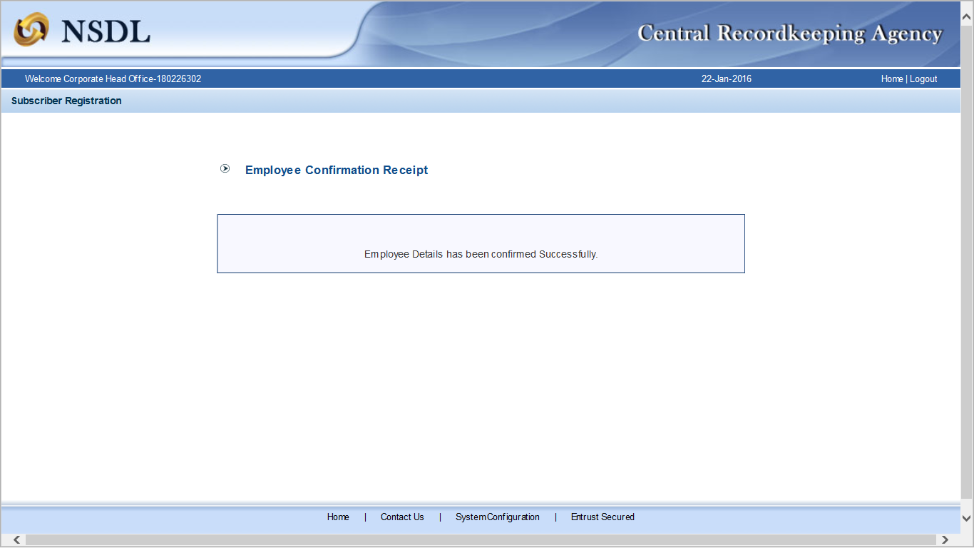

Figure 6

--------X-------

